Word doc.

**Writing on Wednesday** – 13th May 2020

Yes, I know this is Writing Wednesday but I wish to link one new area of maths learning to your Topic; thank you for the cheers – I am so happy you are enjoying maths more. Be honest now, don’t you feel great when you understand – that ‘light bulb’ moment is hard to beat? Also, you are lucky to have people around to support you on this learning journey. I do love the different roads you take. Thank you, for being so diverse. 😊

---------------------------------------------------------------------------------------------------

Right, here we go. Yesterday we investigated perimeter and area problems and today we are you are going to have an introduction to **capacity** and **volume**. Below are two links; the first one is basic but explains things with clarity. For those who would like to extend their understanding, (hopefully, not have it confused) and only **AFTER** watching the first one, then the second link will take you to Mathantics. I think Mathantics is brilliant but that is just my personal opinion. 😊

<https://www.youtube.com/watch?v=GKCE8ohIBqE>

<https://www.youtube.com/watch?v=qJwecTgce6c>

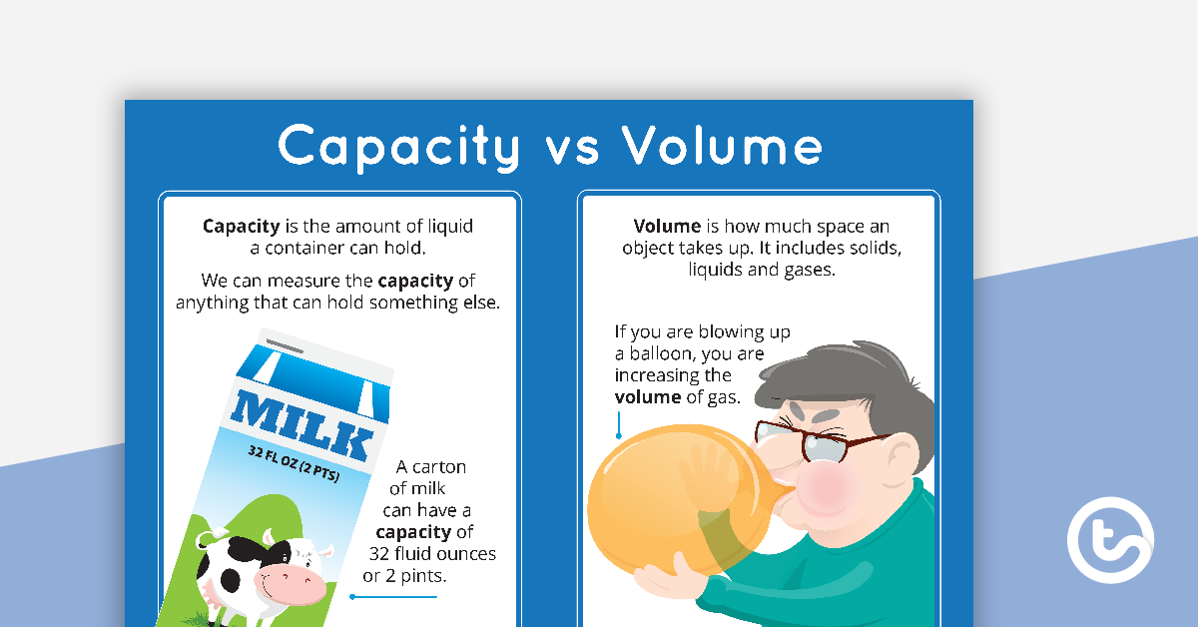

TASK: Design a label for a bottle which would contain some liquid to be used on your pet, for your pet or for its accommodation. You also need to show the back of the bottle with some instructions for use. As you have just learnt about capacity and volume, I would like to see both displayed somewhere. **Here is my example for *‘vit-min drops for cage birds’*. This can be included in your Pet Project. 😊**

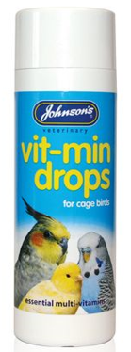

**Back of bottle.**

**Front of bottle.**

**Johnson's Vit-Min Drops for Cage Birds** are a top quality daily multi-vitamin supplement, suitable for all caged birds but particularly beneficial for birds in poor condition, recovering from illness or for additional support before or during the breeding season. Contains approx. 100ml.

**Dosage** based on body weight:

0.5 ml/oz (28 g), with a maximum dosage of 20 ml. Add to drinking water – **DO NOT GIVE DIRECT INTO BIRD’S MOUTH**

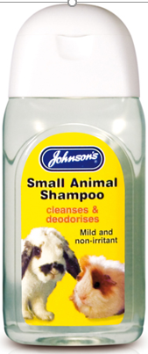

100 ml

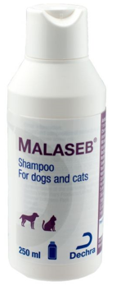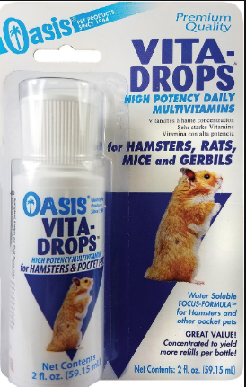

**TIP**: To help you, look at what you have in your home for your pet or even a human and just adapt it or even copy. 😊

TASK: Here is a task from yesterday’s Topic Tuesday, in case some of you would like to do this today to fit in with ‘*writing on Wednesday’*.

You and your family have planned to go on holiday. Your task today is to write out a set of instructions, (algorithm), for the person who is going to look after your pet. (Even if your dog usually goes into kennels, you are going to pretend that a relative is going to come and ‘pet sit’.)

I do not mind how you go about it, as long as it easy to follow and set out in a sensible order, (sequence). Remember, it is always an excellent idea to leave telephone numbers, so you can be contacted in case of an emergency and your Vet’s name and telephone number needs to appear on your instruction sheet too. (This can all be fictious, (made up.)

-----------------------------------------------------------------------------------------------------

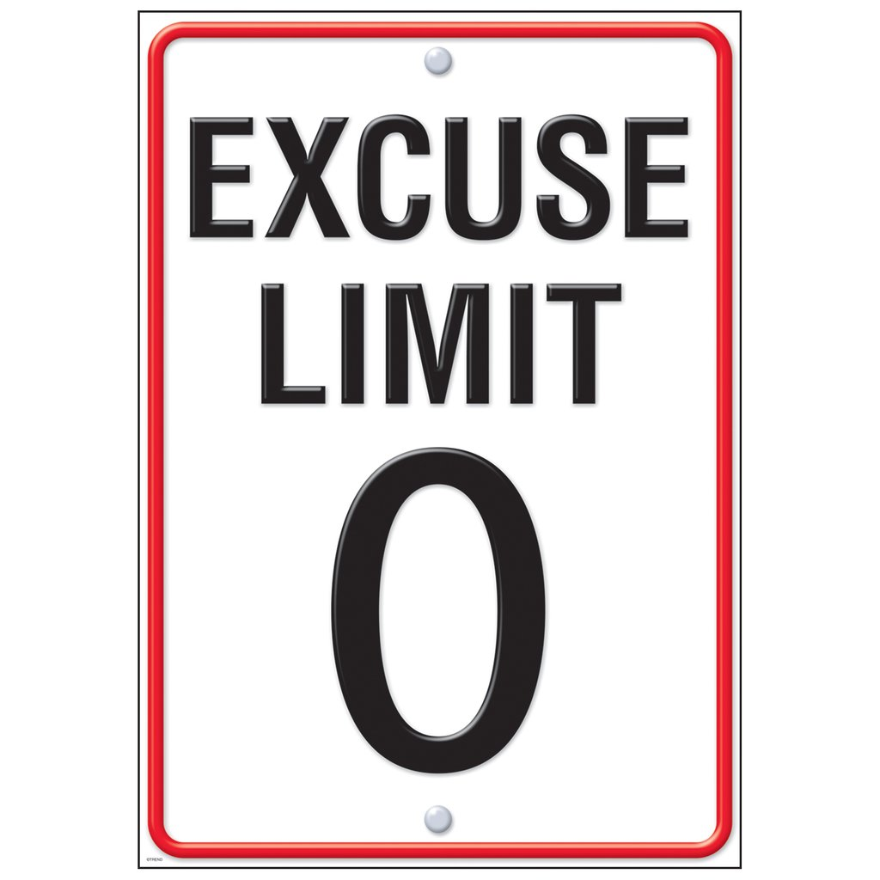**TASK:** Below is a sample of motivational/inspiring etc., posters. Design something along a similar theme. I have also copied a poster for tips - ‘What Makes a Good Poster?’ This I will send to the App. and SeeSaw as a PDF, as well.

|  |
| --- |
| If you do not want to make a poster, then perhaps along the theme of last week, choose which poster you like the best and WHY. |







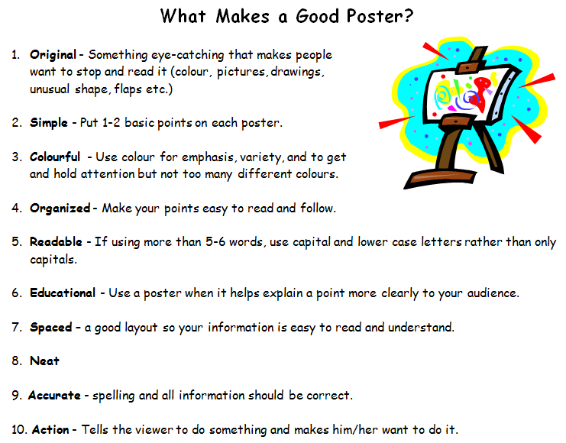

TASK: By stretching a sentence, it is very easy to up-level your writing. Read through the following explanation and look at the examples. Then, either take one of my suggestions or use one of your own to s t r e t c h a s e n t e n c e.

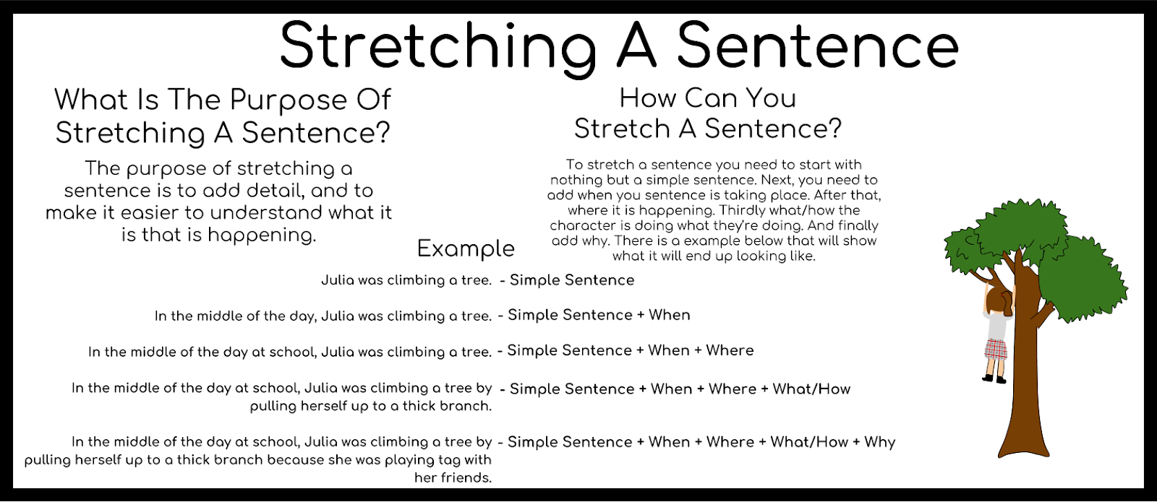

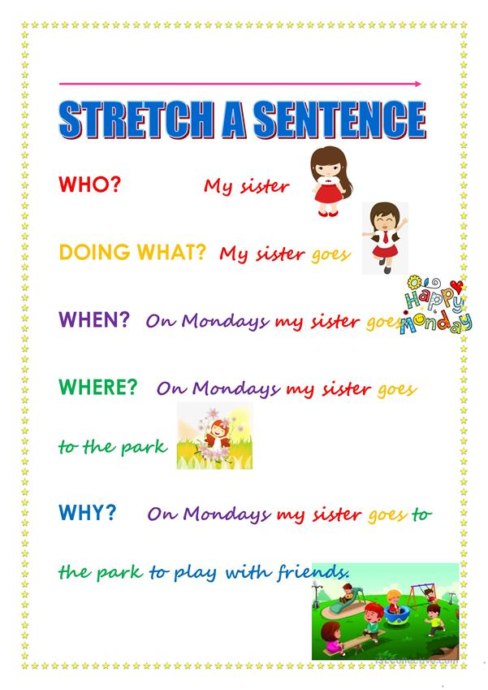**Here are a few examples:**

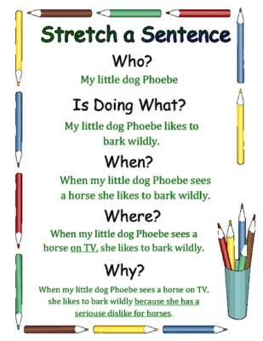

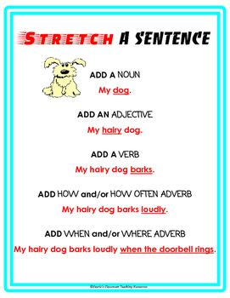

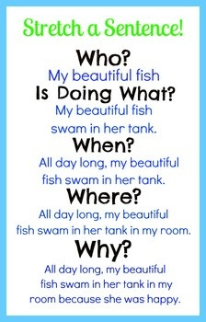

|  |
| --- |
| Note, as long as you have used the 5 ws, then the order in which you use them does not matter; just check your sentence makes sense. **For those who like to raise the bar, add in an H for How?** |

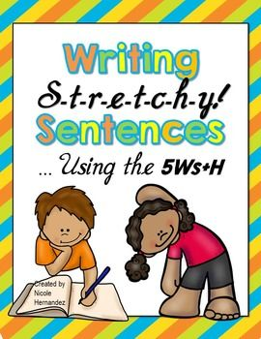

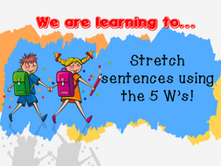

|  |  |  |  |
| --- | --- | --- | --- |
| Carl’s crazy cat… | My Polynesian parrot … | A timid tortoise … | The lazy llama … |

**Take your time and write the very best sentence you can!**

|  |
| --- |
| Challenge question: One of the posters shown above is incorrect. Tell me why and explain your choice. Use your prior learning. |

**TASK:** You will be able to find everything you need to support you with this task in the PDF I shared through the App. and SeeSaw.

Imagine: Continue this story...

“Someone has left the gate open again”, Mr. Hill thought as he trudged across the field…

-------------------------------------------------------------------------------------

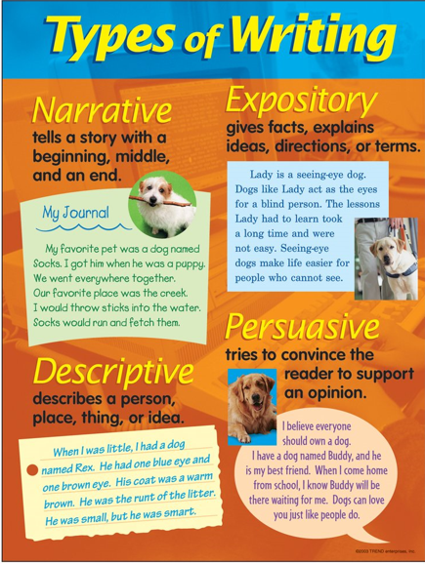TASK: Look at the *‘Types of Writing’* poster. What types did you write today? Can you make a table or list to share with me on SeeSaw? Can you think of other types of writing which could or should be included on the poster?

|  |  |
| --- | --- |
| **Narrative** (fiction/imaginative |  |
| **Expository** (factual) |  |
| **Descriptive** |  |
| **Persuasive** |  |

I hope you enjoy looking through this selection and choosing the tasks which best suit you. 😊

