Word Document

|  |
| --- |
| **Joke**: What do you get if cross a science fiction film with a toad? **Star Warts!**  Brain Teaser answer to follow. |

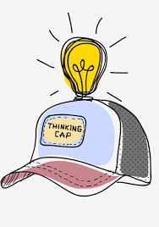Maths Monday – 4th May 2020

Are you wearing one? 😉

**TASK**: Once again, it would be super if you could engage with:

* **SumDog** for 15 minutes

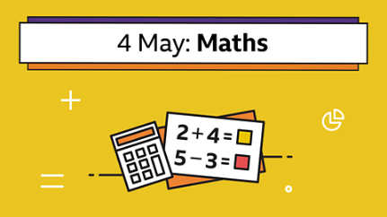

# BBC Bitesize Maths: Today’s focus - Converting pounds and pence. Follow the link below.

<https://www.bbc.co.uk/bitesize/articles/znf4kmn>

* **Snappy maths** – this link takes you to a page of sums for subtraction **without** exchanging (sometimes called ‘regrouping). <http://www.snappymaths.com/addsub/writaddsub/resources/subw1000cnr1.pdf>
* This link is for subtraction **with** exchanging. <http://www.snappymaths.com/addsub/writaddsub/resources/subw1000cmr1.pdf>

On each page there are 22 sums. I neither expect nor wish you to complete them all and definitely not all in one go. I suggest you do 2 or 3 each day.

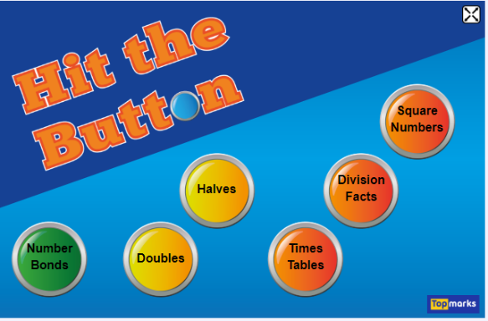These PDFs will be shared in the App. and SeeSaw, hopefully, that way everyone should be able to see them. 😊

* **Hit the Button:**

<https://www.topmarks.co.uk/maths-games/hit-the-button>.

|  |
| --- |
| **Share on SeeSaw which you engaged with. Tell me What Went Well and what you need to practise (Next Steps.)** |

**TASK**: If you only have time to engage with one Maths on Monday Task, could you make it this one? This is fun but also, will help you understand how much maths we use every day!

I would love you to make wee posters, ‘sticky’ notes or some creative idea of your own, to answer this question:

What maths skills do you use when:

* Baking
* Gardening

**Maths skills I use to look after my pet hamster.**

* Looking after a pet

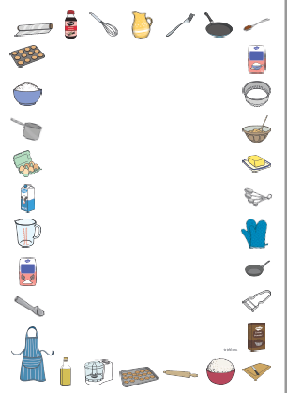

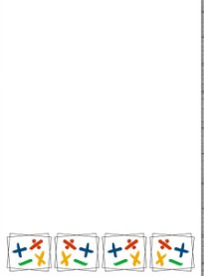

**Maths skills I use when gardening.**

**TASK**: **Star Wars Game**. Remember, one die, two or more dice, so for this game, you will need two dice or one die rolled twice! Good game to support your mental maths. 😊

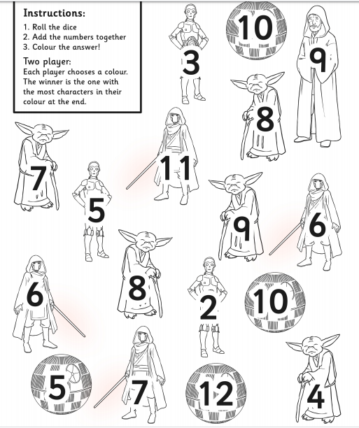This will be attached as a PDF.

Well, at the moment I do not have any answers to the STEM maths ‘pet shop puzzle’ so I thought I would offer it up again as part of your maths on Monday.

**TASK**: I really like this challenge because it is an opportunity to use your problem-solving skills – remember that tool box of problem-solving strategies you made? 😊

