**GROUP 1 AND 2 SPELLING ANSWERS**

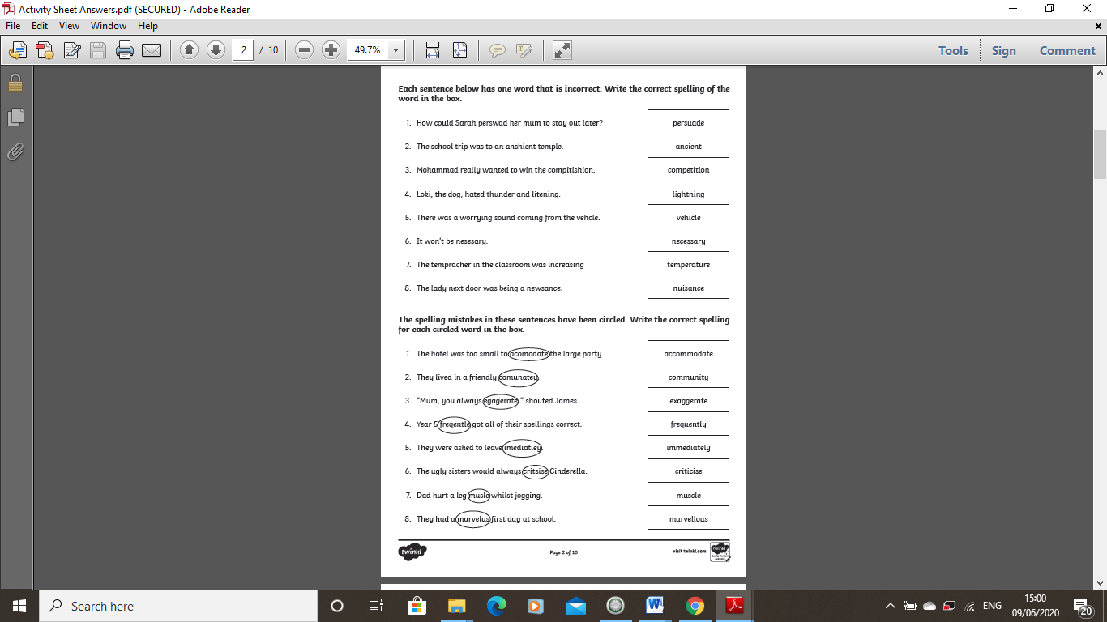

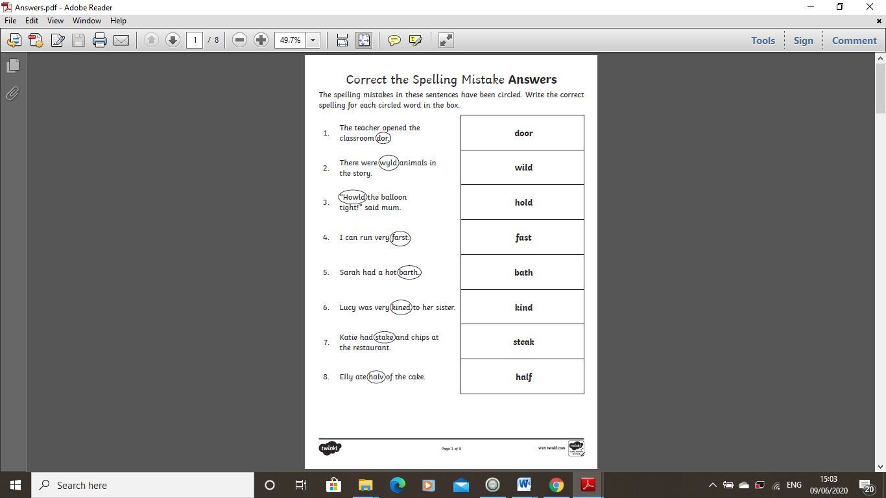

**GROUP 3 SPELLING ANSWERS**



**GROUP 1 MATHS ANSWERS**



**GROUP 2 MATHS ANSWERS**



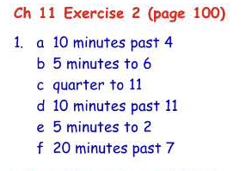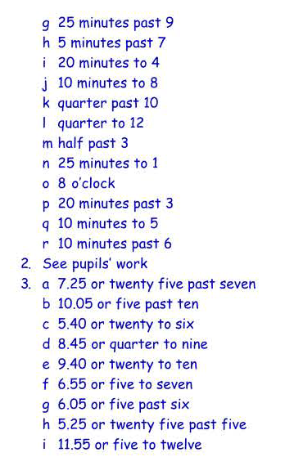

**GROUP 3 MATHS ANSWERS**