**Word doc**.

**Maths on Monday:** As you know I really enjoy numeracy and maths. The satisfaction when I work something out gives me such a buzz. With this in mind, I hope you are going to use your growth mindset and engage with your maths learning with a ‘can do’ attitude. Remember, if you find things a little tricky you can:

* use the support materials I have sent you
* send me a message on SeeSaw asking for my help
* ask some willing member of your family to support
* go on line and find yourself a tutorial to help with your understanding

Keep upbeat and have fun. 😊 Remember the following tasks are in no particular order although, the one I would love all to try is **Sophia’s Daily Mile Decimal task.** 😊

**TASK**: A bit of revision but important. If too challenging, then ask someone to write out 3 subtraction sums with NO exchanging, (regrouping), for you to try. 😊

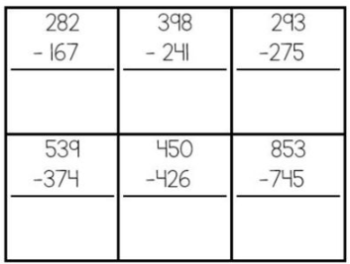

----------------------------------------------------------------------------

**TASK**: I believe the BBC bitesize tutorials and lessons are first-class. Plenty to choose from at your own level of understanding. With a positive approach, this site can really support your progress.

Chili Challenge * <https://www.bbc.co.uk/bitesize/articles/zbkvbdm> x and ÷ by 3

Chili Challenge ** <https://www.bbc.co.uk/bitesize/articles/zvvsy9q> x and ÷ by 8

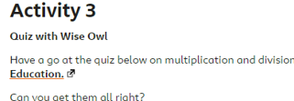Chili Challenge *** <https://www.bbc.co.uk/bitesize/articles/zmbtpg8>

My favourite one. Quiz with Wise Owl . 😊

|  |
| --- |
| Simply, tell me on SeeSaw if you engeaged with Chili Challenge *, ** or *** and What Went Well and your Next Steps. **THANK YOU.** |

----------------------------------------------------------------------------

**TASK**: Watch this tutorial about how to find an average, (new learning):

<https://www.youtube.com/watch?v=95h7qAkz5QY>

Then have a go at the worksheet uploaded via App. and SeeSaw (PDF). Use your knowledge of the link between x and ÷.

|  |
| --- |
| Share your answers on SeeSaw, along with a comment about your learning. I will post answers to those who complete this task to let them self-mark. 😊 |

---------------------------------------------------------------------------

**TASK**: Here are some of the times Sophia has recorded whilst running her Daily Mile. Thank you, Sophia for letting me use them. 😊 Below are a number of problems for you to try. Enjoy!

1. Put them in order, starting with Sophia’s quickest time.
2. Round each number to the nearest whole number.
3. Add these rounded numbers together.
4. Now, add the **actual** numbers together to get an exact figure. Is it close to your rounded numbers total? If not, what does this tell you?

**TIP for number 4**: Break the question down into manageable chunks. For example, add two numbers together and circle this answer. Then, add the next two numbers and circle that answer. Continue doing this until you have five circled answers. Can you work out what to do next? I am sure you can.

|  |
| --- |
| **Remember** to write down ALL your thinking. Also, think about the importance of keeping numbers in the correct column -place value. |

**Extension Questions**:

1. What is the difference between Sophia’s slowest and quickest time?
2. Using the total of the **rounded** numbers, find Sophia’s average time.
3. Using the actual times and a calculator, find out Sophia’s actual average time.

**Sophia’s Times**:

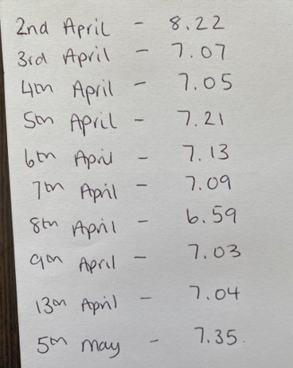

**TASK**: Quite a number of you have asked for some more of Maths Mysteries, so I have uploaded one through the App. and SeeSaw. Remember to show lots of working out, check your answers make sense and find out who caused chaos with the missing macaws!

dun, dun, dun …

|  |
| --- |
| If you decide to engage with this task, then what is important to share with me, is not just the answers but all that wonderful working out which will highlight your understanding. Remember, this can be completed with someone in your family to add to the fun! Good luck! 😉 |

I will share answers with those who ‘have a go’ with this task through SeeSaw. If you end up with an incorrect answer but you can understand where and why you went a little of course, **then the learning is so very meaningful and valuable and I applaud that.** 😊

|  |
| --- |
| Remember to have a go at today’s brain teaser and check out the Art competition; both shared through this morning’s App. |