Times Tables Tuesday

Good Morning Primary 5,

Today your maths task is to revise your times tables. Listed below are a selection of activities for you to choose from and as always, feel free to be creative and think up your own interesting ways. Please share your work in the pupil folder 😊.

1. Create a times table grid like the one below:

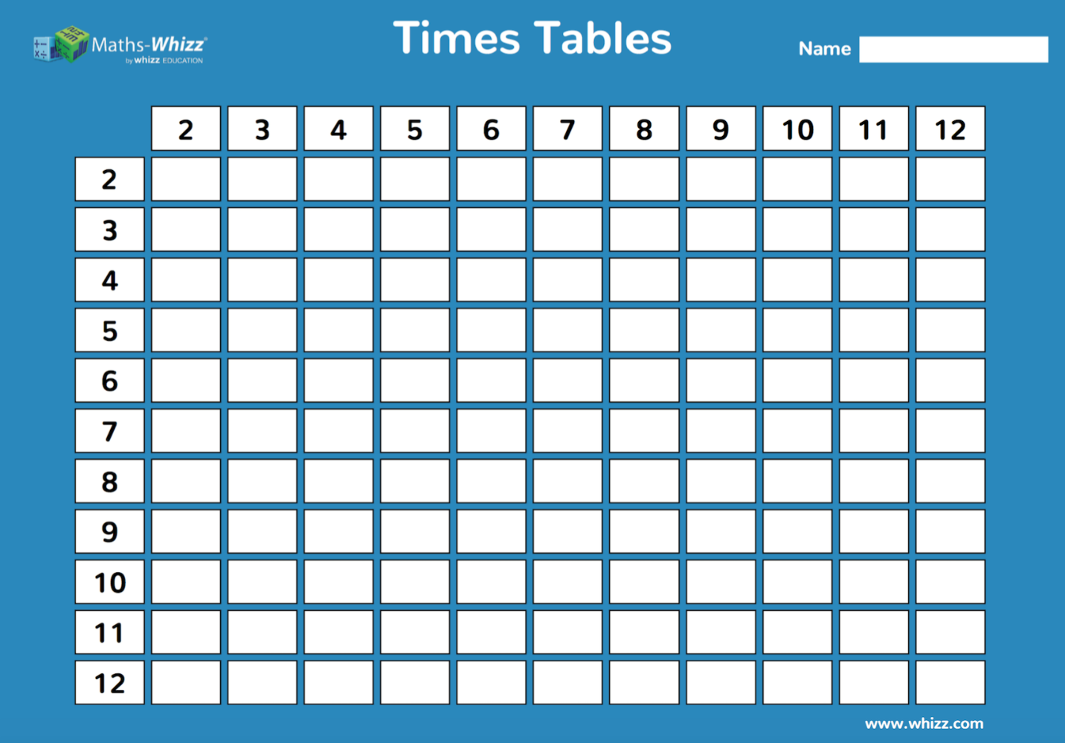

1. Create a times table quiz. If you know your times tables well enough to teach someone else, then you know them really well 👍.
2. Take your learning outside and uses nature to write out your times tables 🌳.

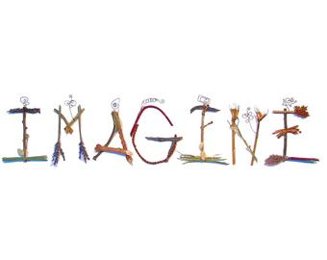

1. Create a times tables poster. Make it colourful and eye catching but also useful for learners 🤔.
2. Find an online game to help you practise 💻.

Remember to challenge yourself: don’t just revise the times tables you’re confident with, try the ones you’re not sure about. Now would be a good time to have a think about your 7- and 8-times tables, if you’ve not already looked at them 😊.