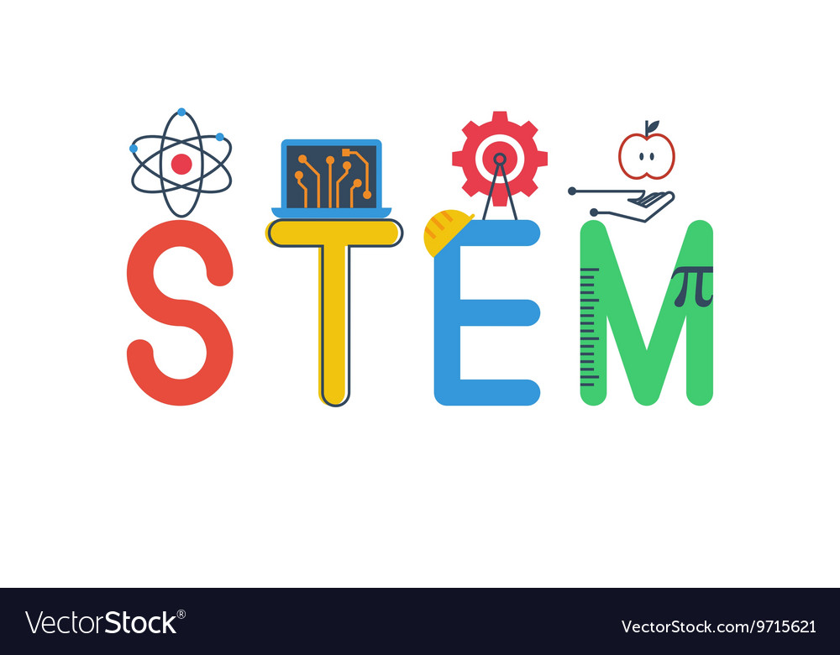

Good Morning Primary 5,

Welcome to STEM Friday, the end of another week already! I hope you have all had a good week and have learned something interesting or brushed up on a few skills.

This week our STEM challenge is all about Chemistry. I’ve set out three challenges below that have Chemistry at their centre but each one asks a slightly different question, again linked to Vikings.

Finally, there is a more artistic and creative challenge for you at the end of the Chilli Challenges.

Remember that you don’t have to do all the challenges, if you would rather select the one that tests your skills and understanding the most, then that's absolutely fine.

I look forward to chatting with you all.

Mrs Cameron



Viking blacksmiths made things out of iron. Iron starts off as a rock that is melted using fire. Then, the iron is beaten with a hammer to make things, for example a horseshoe, a knife or an axe.

We can use a hammer to change the shape of some hard materials. Other materials don’t change their shape, they just shatter.

1. Can you make a table of different materials to show the effect of hitting them with a hammer? Perhaps you could test your materials (if it is safe to do so!)
2. Can you think of other ways to change the shape of a material apart from hitting it with a hammer?



Vikings used rocks for sharpening weapons, grinding grain into flour and as an abrasive for smoothing hard skin or rough wood.

1. What do you think makes rocks good for sharpening, grinding and smoothing?
2. Can you select and test different rocks, grouping them into rocks suitable for each job?



Vikings used chemistry in a variety of ways from baking bread to burning down Saxon villages. These are examples of irreversible changes: once the bread is baked you can’t get the flour back; you will need to rebuild a burnt-down village from scratch.

1. What other examples of irreversible changes can you find at home?
2. Vikings made glue out of milk. Can you find out how they did it and see how well it sticks things?

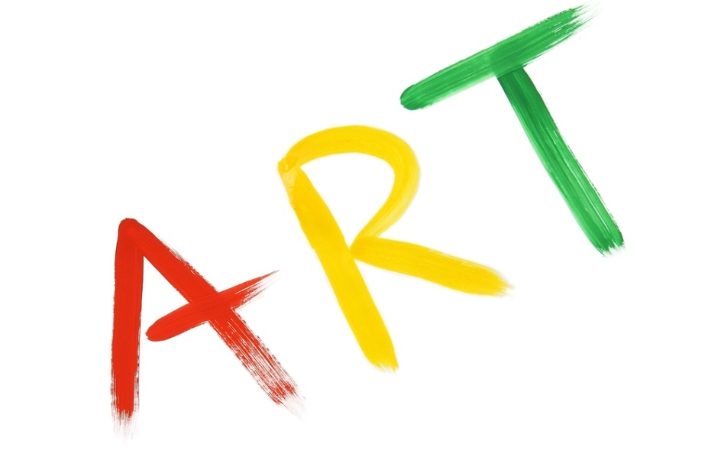

Time to get creative! below are instructions on how to make a Viking brooch. The link is here if you wish to look at the website directly: <https://angelicscalliwags.com/2012/11/22/how-to-make-a-viking-brooch/>

If you don’t have all the materials at home, perhaps you could think of different ways to make your brooch.

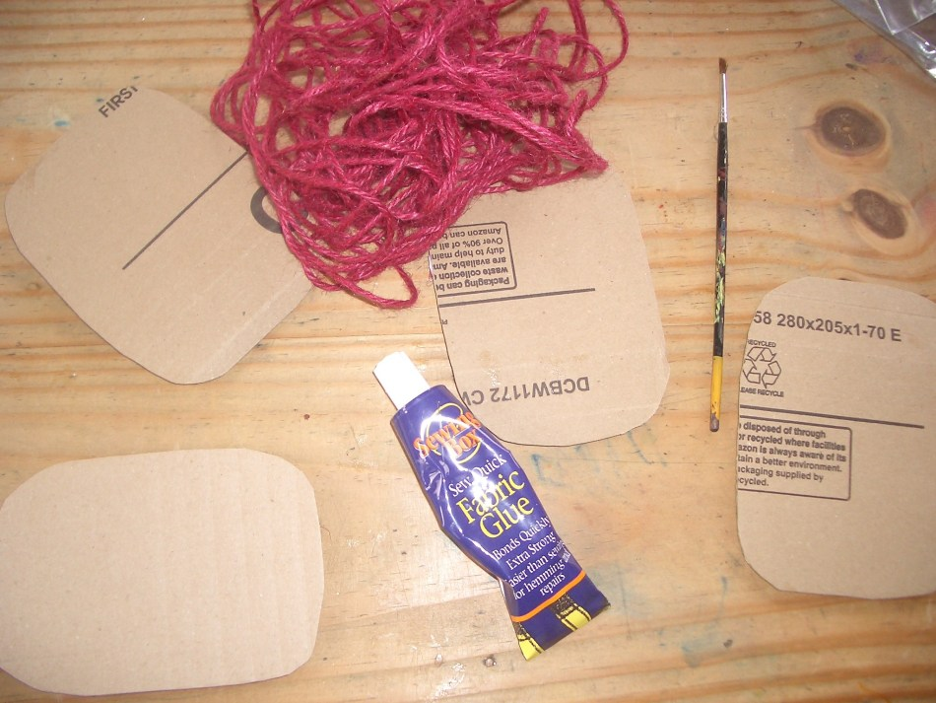

Gather some card, glue and string. We used fabric glue but really any strong glue would work. 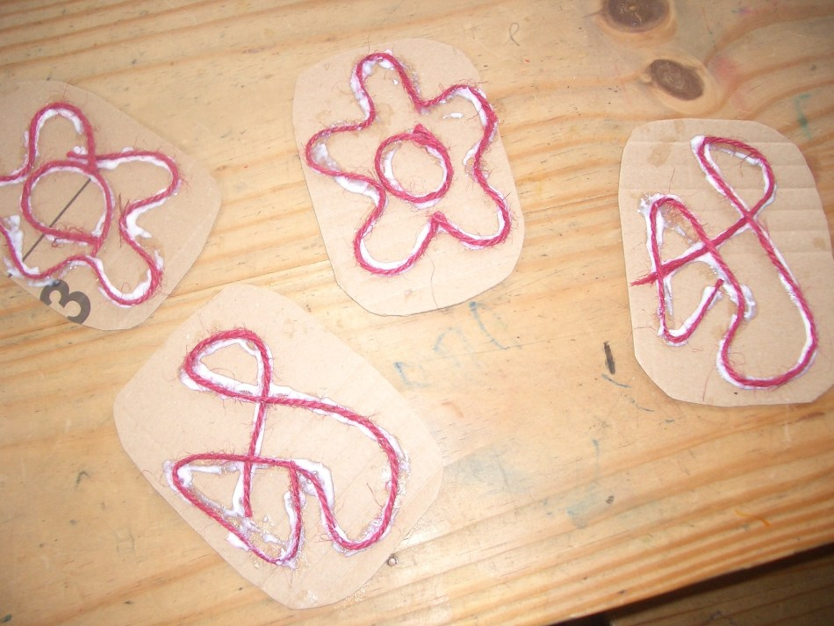

Attach the string to the card in a pattern of your choice.

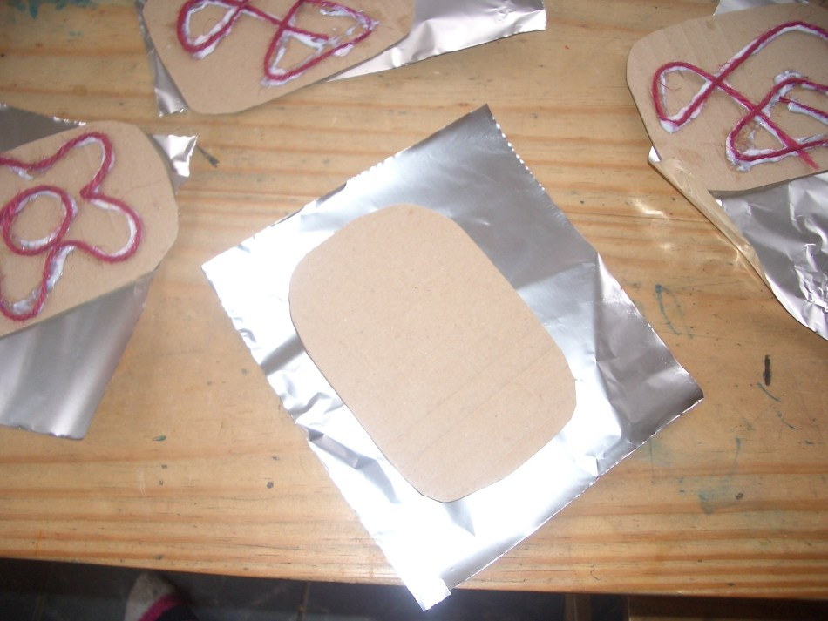

Allow glue to dry. Place string side down on a square of foil

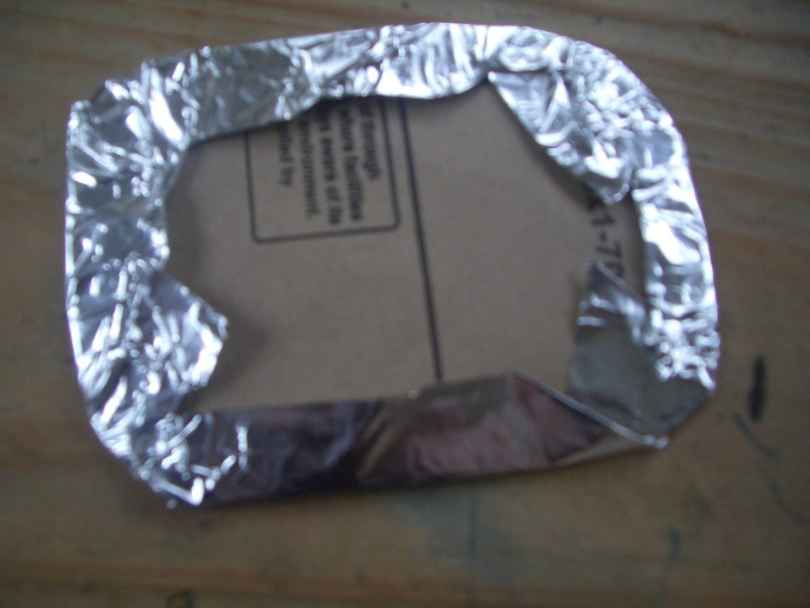

Turn over the edges and stick with tape

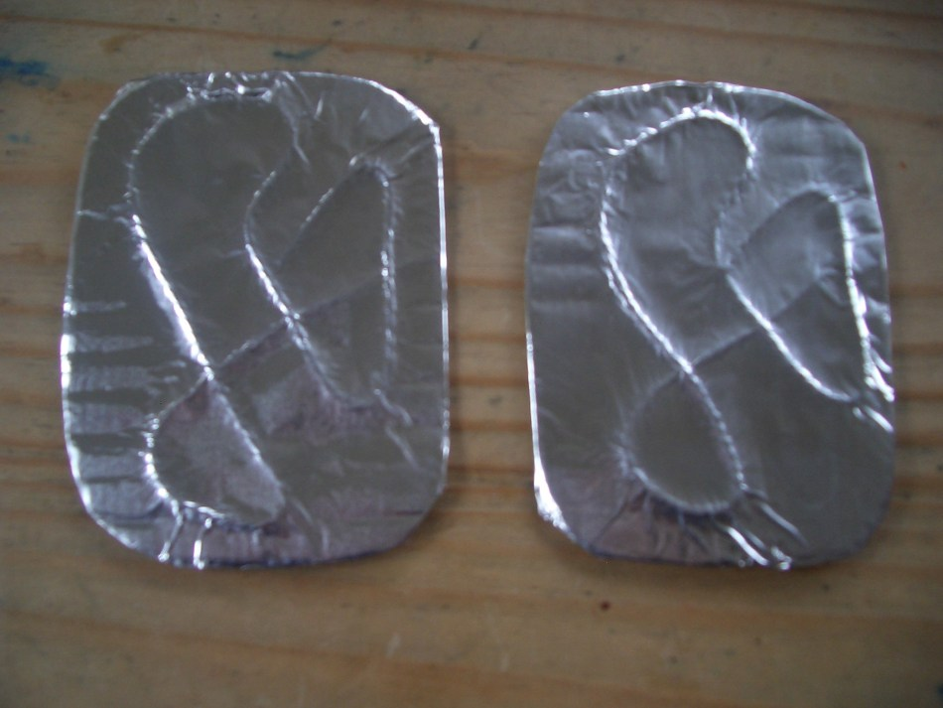

Rub gently using your fingers to show the raised string pattern

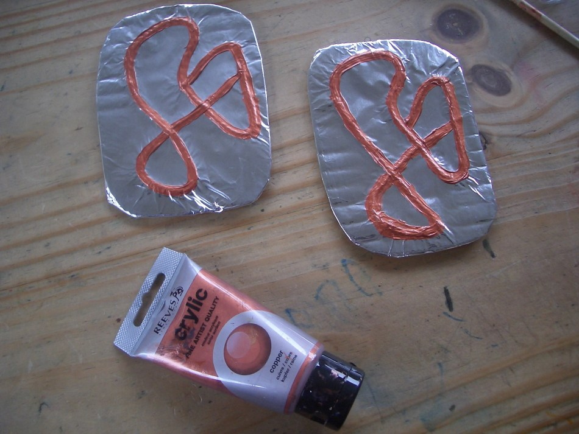

Paint in bronze over the raised string area using acrylic paint.

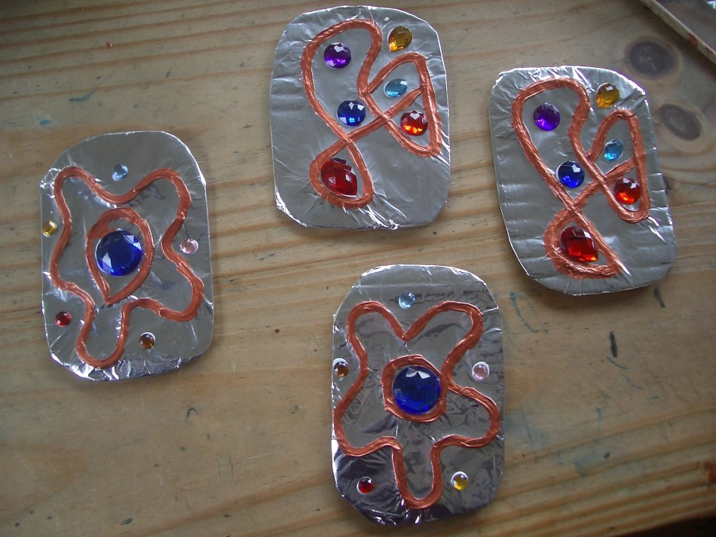

Add decoration of your choice.