**Thursday, 4th June 2020**

**Thought for Today …**

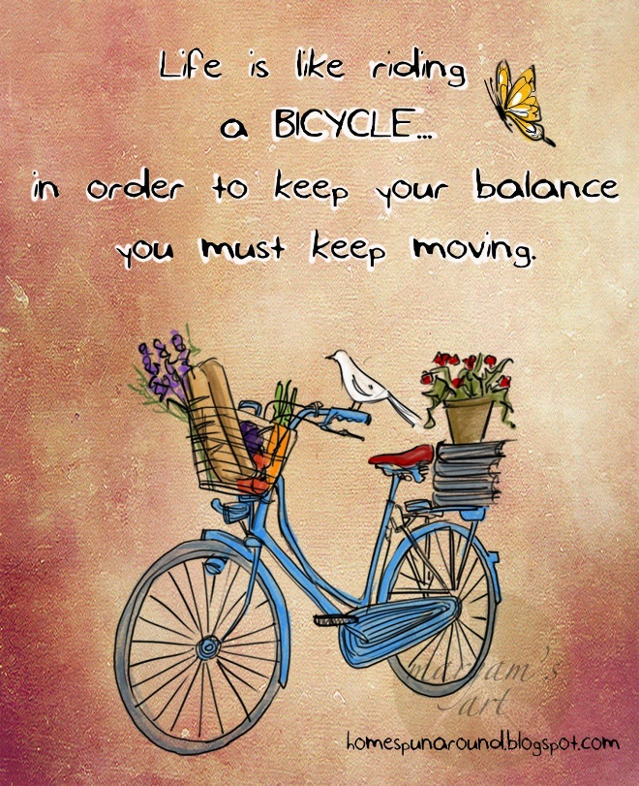

**Literacy:**

**TASK: Spelling Review:** Hopefully this is set up on Education City but for some reason it did not load the same as yesterday. If it is not there, then no worries. Just let me know and I will go back to the drawing board. 😊

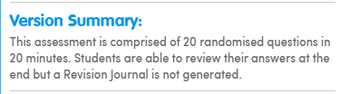

**TASK: Dictionary:** Look up the meaning of ‘idiom’. Like some of you did yesterday and thank you for that, record the meaning in SeeSaw. 😊

**Brain Break of your choice**

**TASK: KAL: New Learning:** An idiom is a form of figurative language. What, I hear you ask, is ‘figurative language?

|  |
| --- |
| **Figurative language** is a word or phrase that does not have its normal every day, literal **meaning**. It is used by the writer for the sake of comparison or dramatic effect. For example, authors use similes, metaphors, hyperbole, idioms, personification etc., to make their stories more interesting. |

Find an idiom to fit into each of these categories and remember to say what it means. I have given you an example of each. 😊

|  |  |  |
| --- | --- | --- |
| Every day idiom. | Body part idiom. | Animal idiom. |
| **Piece of cake** - Something very easy. | **Cross your fingers** - For good luck. | **A bull in a china shop** - Someone who is very clumsy. |

**TASK: Writing and art skills:** Time Capsule fun!

Contained in the **PDF** are tasks for you to complete; if you wish. 😊

* Dear Me …
* About Me …
* An Interview With …
* My Hopes and Dreams …
* My Hand and Foot Print …
* In the News …
* Portraits …
* Planning Sheet – My Time Capsule Will Include …

**Mid-morning breaktime. Free choice! 😊.**

**Numeracy:**

**TASK:** Thank you to those who engaged with a spot of revision where contractions are concerned; only Zak found them all. Well done. 😊 The one that slipped through the net was … well actually, here is something for all of you to have a go at. Below is a contraction, write it out in its full form.

|  |
| --- |
| **o’clock** |

**TASK: Time: Consolidation -**

|  |
| --- |
| We are learning to write fractions of hours as hours and minutes |

I have uploaded a question sheet as a **PDF**. On the PDF is this time wall – use it to help you! 😊

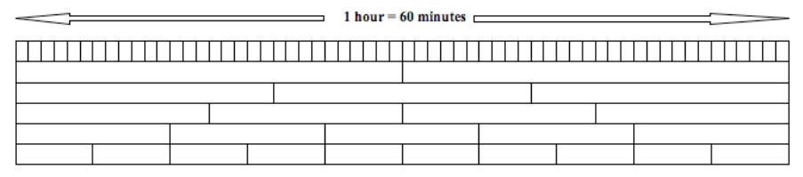

**Brain Break of your choice**

.

**TASK: Time: Understanding and application:**

If you decide to do this task, I would really appreciate you engaging with it to the very best of your ability. If I was delivering this in class, you know I would be inviting you to think about whether or not you had produced your best work. Can you remember what you did when you knew it wasn’t? **😊**

I would like you to design a poster showing all the different ways we can measure/record the passage of time. Underneath each illustration I would like to write what it is – nothing more or the poster will look too crowded. By planning this activity, you will have a good idea how big a piece of paper or card or material you will require.

To be successful you will have to research this. Remember, this does not automatically mean using a device. Why not ask everyone in your family first or phone a member of your family?

|  |
| --- |
| Please do not produce a poster that is full of different types of clock; that is not what this task is about. If unsure, message me through SeeSaw. |

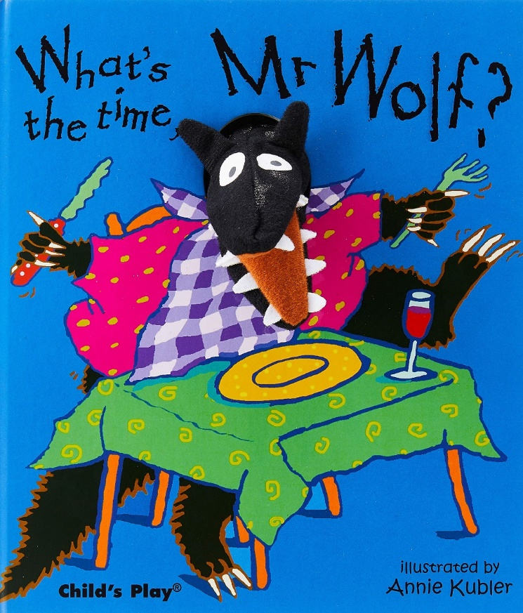

Lunchtime!