Literacy 16.6.20
Comprehension Task

Today there are three chilli challenges to choose from.
For chilli 1 I don’t want you to cut the questions out, I would just like you to answer them in full sentences please.

For chilli 2 and chilli 3there are answers attached for you to self-assess when you have completed the literacy task. Make sure you are answering in full sentences. The answers that are there for you to mark against aren’t always written in full sentences. We worked on this a few weeks ago so everyone should now be answering fully!

Enjoy!

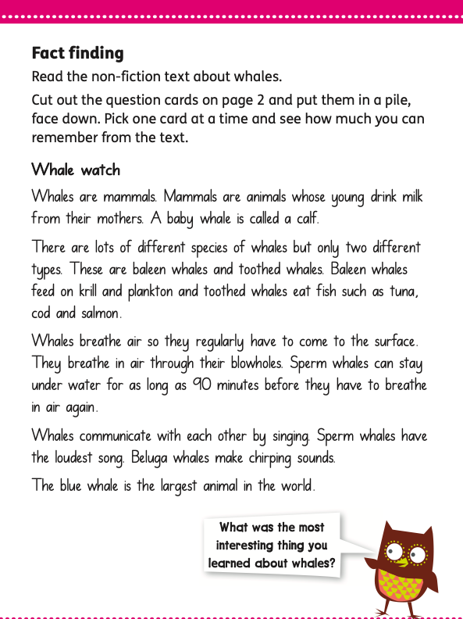
Chilli 1

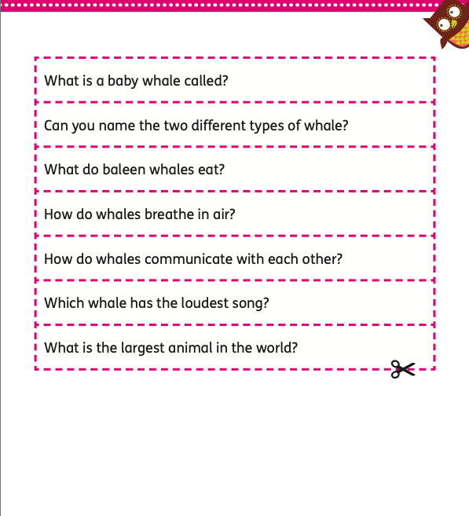

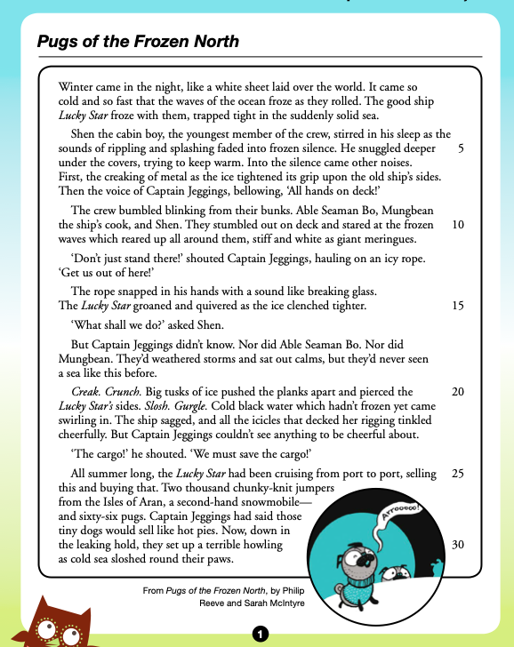
Chilli 2
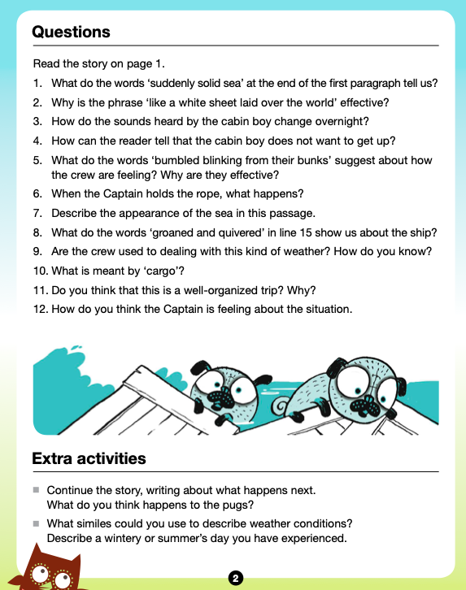
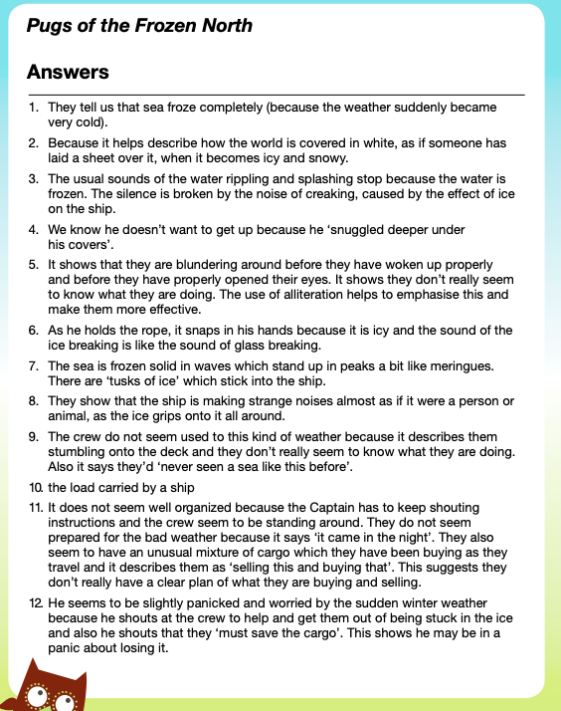
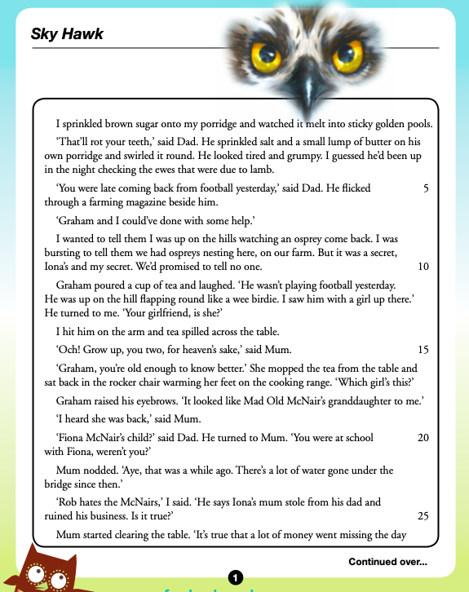
Chilli 3

