Numeracy 22.6.20

Mental Maths

Here are three chilli challenges for you to try. Time yourself for each row and see if you can beat your time! Try each row several times until you get your best time. Try to do all of the calculations in your head!

Chilli 1

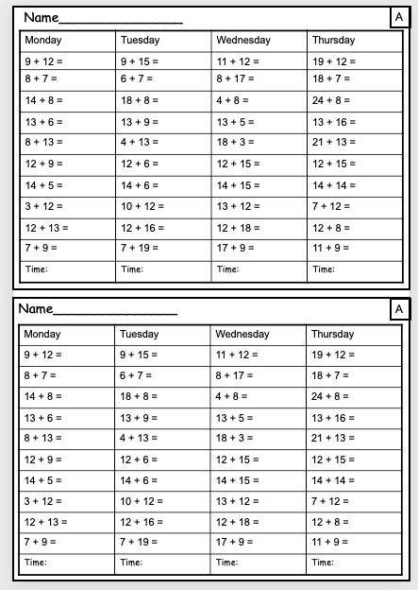

Chilli 2
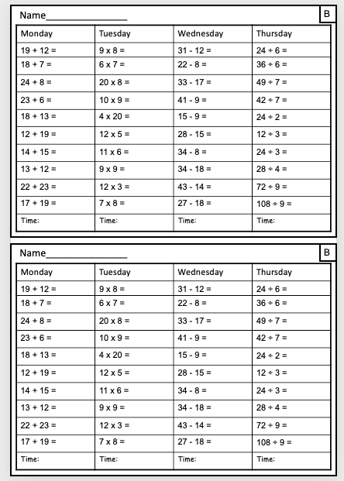

Chilli 3
