Literacy Task 4.6.20

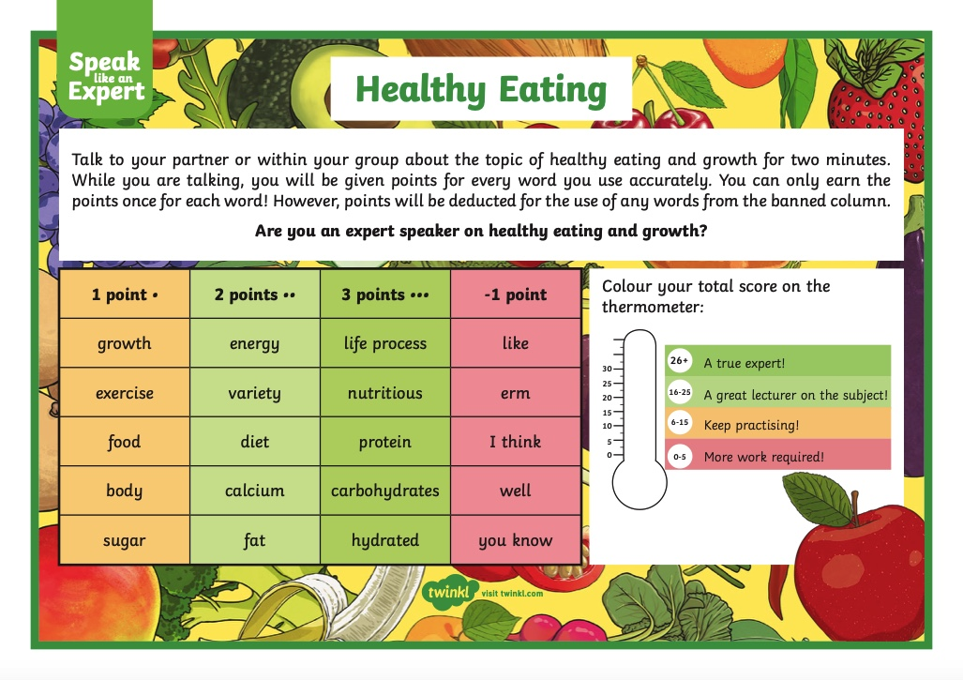
Listening and Talking Skills
Instead of talking with a partner about the topic healthy eating and growth, I would like you to search the internet for information about this and take some notes.

When you have completed that you can then tackle the speaking task. I am happy for you to send me in your points, but it would be even better if you could send me a video or a voice recording (I don’t need to see you) of your expert speaking!

You can prepare what you are going to say and use some notes to read from or you can use your memory from your internet research and have the desired words (document above) in front of you.

I am interested to see how well this goes – I am partial to use the words which minus you a point (erm, I think, etc!)

Good Luck!!!

