**Numeracy Task**

**Mental Maths 25.5.20**

**Here are some mental maths tasks for you to try (you will sometimes have to do some writing and working out but I would like you to try and use your mental skills too)**

**You may find some of these tasks tricky so choose the ones that are manageable but challenge you a little!**

**If you only manage one of these tasks you can move onto practising your mental recall of times tables. This will support you in further mental maths challenges.**

**Intersection Sums Sudoku**

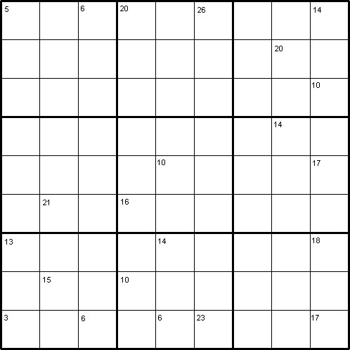

**The Rules of "Intersection Sums Sudoku"**

Like the standard Sudoku, this Sudoku variant consists of a grid of nine rows and nine columns subdivided into nine 3×3 subgrids. Like the standard Sudoku, it has two basic rules:

1. Each column, each row, and each box (3×3 subgrid) must have the numbers 1 to 9.
2. No column, row or box can have two squares with the same number.

Like other Sudokus published by NRICH, this puzzle can be solved with the help of the numbers in the top parts of certain squares. These numbers are the sums of the digits in all the squares horizontally and vertically adjacent to the square.

**A Short Demonstration**

The square in the bottom left corner of this Sudoku contains the number 3. 3 is the sum of the digits in the two adjacent squares, which therefore must contain the digits 1 and 2.  
In the beginning, we do not know whether we should put 1 or 2 in the square (8,1) or in the square (9,2). If we put 1 in the square (9,2) and 2 in the square (8,1), we have to put 3 in the square (8,3) and 2 in the square (9,4) because of the small clue-number 6 in the square (9,3). If we put 2 in the square (9,2) and 1 in the square (8,1), we still have to put 3 in the square (8,3) and 1 in the square (9,4). We find that 3 will go to the square (8,3) regardless of where we put the rest of the numbers.  
  
At least the answer for one square is confirmed. That's not too bad after all. Sooner or later, we shall be able to obtain the answers for the squares (8,1), (9,2) and (9,4) as we try to solve the rest of the puzzle.

**Number Detective**

Calling all detectives! You will need to think creatively, use your reasoning skills and your problem solving strategies to find the mystery number from the list below.



* The number has two digits.
* Both of the digits are even.
* The digit in the tens place is greater that the digit in the ones place.
* The ones digit is not in the three times table.
* The tens digit is not double the ones digit.
* The sum of the two digits is a multiple of five.

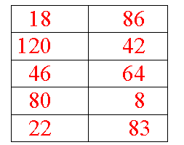

# Three Neighbours

Take three numbers that are 'next door neighbours' when you count. These are called consecutive numbers.

Add them together.

What do you notice?

Take another three consecutive numbers and add them together.

What do you notice?

Can you prove that this is always true by looking carefully at one of your examples?

# Consecutive Numbers

*Well I wonder how often you have noticed that there are numbers around the place that follow one after another* 1, 2, 3 ... *etc.? Sometimes they appear in reverse order when a countdown is happening for a launch of a rocket. But usually they happen in an order going up, like when you read through a book and notice the page numbers. These kinds of numbers are called consecutive numbers, you may have heard of the word before - it simply means that they are whole numbers that follow one after another.*  
  
*This investigation uses the idea of consecutive numbers and gives us other numbers to explore.  You may very well discover things that NO ONE else has discovered or written about before, and that's GREAT!*  
  
  
**So this is how it starts.** You need to choose any four consecutive numbers and place them in a row with a bit of a space between them, like this:  
  
4, 5, 6, 7  
  
When you've chosen your consecutive numbers, stick with those same ones for quite a while, exploring ideas before you change them in any way. Now place +and − signs in between them, something like this :  
  
*4 + 5 - 6 + 7*  
*4 - 5 + 6 + 7*  
  
and so on until you have found all the possibilities. Are you sure you've got them all?  You should include one using all +'s and one that includes all −'s.  
  
  
Now work out the answers to all your calculations (e.g. *4 - 5 + 6 + 7 = 12* and so on).  
  
Now try other sets of four consecutive numbers and look carefully at the sets of answers that you get each time.  
  
Are you surprised by anything you notice?  
  
It is probably a good idea to write down your 'noticings'. This can lead you to test some ideas out by starting with new sets of consecutive numbers and seeing if the same things happen in the same way.  
  
You might now be doing some predictions that you can test out...  
  
  
FINALLY, it is good to ask the question "I wonder what would happen if I ... ?"  
You may have thought up your own questions to explore further. Here are some we thought of:  
  
"What would happen if I took the consecutive numbers in an order going down, instead of up?"  
"What would happen if I only used sets of three consecutive numbers?"  
"What would happen if I used more consecutive numbers?"  
"What would happen if I changed the rule and allowed consecutive numbers to include fractions or decimals?"  
"What would happen if I allowed a + or − sign before the first number?"