Hello P5,

I hope you have enjoyed your long weekend. It was scorching hot!

You might have noticed that I have renamed our Wednesday file to ‘Revision Wednesday’. I have done this because on the days I am not on TEAMS to help you with questions and marking, I thought it would be useful for you to be completing activities independently. Mrs Stokoe is available to help you with anything, but I thought it would be a good opportunity for you to practise those Maths skills you have already learned with Mrs Innes.

This week I have suggested some online games to revise your place value knowledge. Feel free to explore other games as well, these are just suggestions.

If you would like to take your learning outside, perhaps you could try creating numbers using whatever you have to hand at home and then asking a family member to guess the number you have created. You could test their place value knowledge by asking them the place value of the digits in the number. For example, you might use chalk, Lego, sticks, stones…. just like the pictures below:

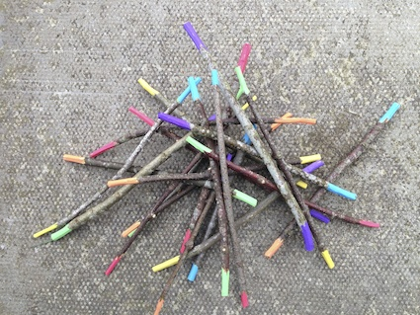

Each colour represents a different place value, one colour for ones, another for tens, a third for hundreds etc.

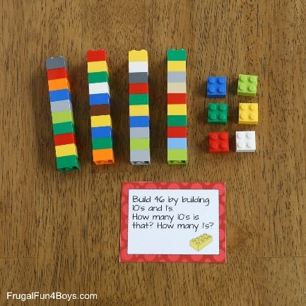

<http://www.math-play.com/Place-Value-Millionaire/place-value-millionaire-game_html5.html>

<https://www.topmarks.co.uk/place-value/place-value-charts>