Monday, 25th May 2020

**Literacy:**

**TASK: Watch Newsround**: Choice one Newsround item of interest and record or video yourself:

* Tell me what the news item was.
* Why you choose it.
* Does it link to any part of your learning/life?

­

_________________________________________________________

**TASK: Reading:**

* Read a book for 10 minutes.
* 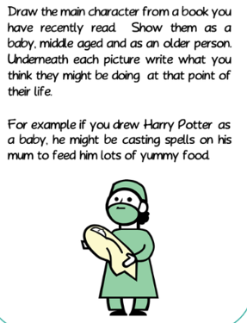Then …

**Brain Break of your choice**

**TASK: Dictionary:** Look up or find out the meaning of the following words. These words will all link to other areas of your learning. **😊**

1. **Protagonist** – pro/tag/o/nist
2. **Antagonist** - an/tag/o/nist
3. **Intersection** – in/ter/sec/tion

_________________________________________________________

**TASK: Cursive Handwriting -** Practising**-:** Write out the three dictionary words in your best handwriting. 😊

_________________________________________________________

## TASK: KAL/Spelling - Consolidation: PDF

These differentiated plurals worksheets will help you develop your understanding of irregular plural nouns. On this worksheet, you are tasked with changing singular nouns into their irregular plural. You can use your understanding of this important spelling rule to answer the questions.

|  |
| --- |
| **Irregular plural nouns are irregular nouns in the plural form.  An irregular noun is a noun that becomes plural by changing its spelling in other ways instead of adding an *‘s’* or *‘es’* to the end of the word. This change can happen in a variety of ways.  For example: one child (singular) becomes children for the plural.** |

**Mid-morning breaktime. Grab yourself something to drink, healthy snack and get outside for some fresh air 😊.**

**Numeracy:**

**TASK: Consolidation: Choose to complete either A or B or both. 😊**

|  |  |  |  |
| --- | --- | --- | --- |
| **A.** Number story using + and – for these 3 numbers. Remember, you can only  USE these 3, no others! | | **B.** Number story using x and ÷ for these 3 numbers. Remember, you can only USE these 3, no others! | |
| 87 141 54 | | 24 144 6 | |
| **No calculators to be used! 😉** | |

_________________________________________________________

**TASK: Revision: At least 10 minutes of SumDog or educational maths game you like to use – choose an area of challenge NOT something you can do without much thinking! 😊**

_________________________________________________________

**TASK: Prior Learning to be Applied:**

Waggle Dance: Watch this clip, then answer this question.

Ben the worker bee, performers his waggle dance to Betty Bee. The dance lasts for 8.5 seconds. How far will Betty Bee have to fly to find the delicious nectar? Can you give your answer in three different ways?

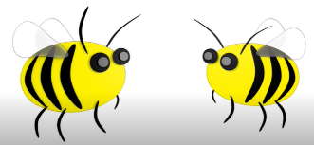 <https://www.youtube.com/watch?v=pb1lRI-YePU>

_________________________________________________________

**Brain Break of your choice**

**TASK: Problem Solving Strategies to be Applied:**

15 identical blocks are lined up as shown. The length of each individual block is twice its width.

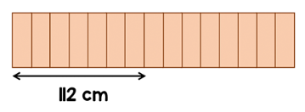

If all 15 blocks are then laid end to end lengthways, what is the total length of all the blocks?



|  |
| --- |
| **Steps for Success**:   * To show ALL calculations, to reflect wonderful thinking. * To write down, (record) thinking in a way that makes sense and is easy to follow. * To highlight the answer, (double underline or draw a circle around it or colour highlighter or …) * To write What Went Well, (WWW). * To write next steps AFTER the task has been marked by another member of family or the answer has been shared and self-marked. |

**TASK: Angles**

**New Learning**

1. You are now going to watch a *Mathantics* lesson which will introduce you to angles. Some of you may already know a little about angles but it is still worth watching. This clip lasts less than 8 minutes so **…**

**… grab yourself something to drink, healthy snack and sit back and enjoy.**

**Mathantics** - <https://www.youtube.com/watch?v=DGKwdHMiqCg>

1. Look at the ‘*Angles’* poster (**PDF**). This is your support resources for future learning on angles. If you do not like it, then why don’t you make your own or find one that suites you better online? 😊
2. SeeSaw activity live before ‘*school’* lunchtime. 😊

**Lunchtime 😊**