**Writing Wednesday** – 29th April 2020.

Q: What did the dog say when he sat on sandpaper? **A: Ruff**!

**Pet brain teaser**:

Three people bought a pet one day. Their names were Zach, Rachel, and Hubert. The animals they bought were a snake, a parrot, and a guinea pig. They bought their pets for £100, £50, and £25.  
  
Can you find out which person bought which animal for which amount of money using these clues and post up your answer in SeeSaw. 😊  
  
1. Zach is allergic to birds.  
2. Hubert couldn't get the £100 pet, so he bought the snake.  
3. Rachel saved £10 a week for ten weeks in order to get her pet.  
4. The mammal was £25.

Answer to yesterday’s brain teaser.

1. John - Dog - March  
2. Sally - Hamster - August  
3. Chloe - Cat - October

As you know this is writing Wednesday but it would be super if you also manage to fit in a little maths into your day and maybe some reading?

For those who like a maths challenge, then here is a treat for you. Work with adult or older sibling or maybe just leave it for an adult to do to keep them busy! 😉 At first glance you may think it is too hard but if you make a table or draw it out you will definitely manage to arrive at an answer. Remember though, even if the answer you get is not correct BUT you have tried and written down all your thinking, then, in my opinion, you are a winner. Good luck.

Camp Pineview’s cook, Margaret Johnson, was just about to begin preparing the picnic lunch for all the campers. She already knew she needed to fill 55 bowls of the same size and capacity with the same amount of food. When she was done, she decided to read the guidelines for the picnic, just out of curiosity. The guidelines said:  
  
1. Every camper gets their own bowl of soup.  
2. Every two campers will get one bowl of spaghetti to share.  
3. Every three campers will get one bowl of salad to share.  
4. All campers are required to have their own helping of salad, spaghetti, and soup.  
  
After some rapid calculations, Margaret was able to figure out how many campers were going to the picnic. Can you?

|  |
| --- |
| **Hint: If there were only six campers, there would be six bowls of soup, three bowls of spaghetti, and two bowls of salad.** |

Right, after all that brain power time for ‘move to learn’ break. If you do not fancy a physical wake up just now, come back to this link later on in the day.

<https://www.youtube.com/watch?v=t8e4Xtr5_W0>

**Writing Wednesday**

Today’s choices will be:

* **TASK**: Write out a timetable **or** a page of a diary for a week day during ‘home-schooling’.

**A Day in the Life of (insert your own name**). Here is an example of a diary extract.

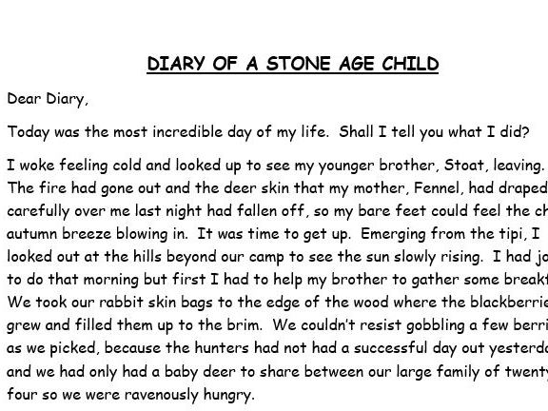

**--------------------------------------------------------------**

* **TASK**: In a shop window you see a pet for sale. Design an advert for a pet for sale. The pet should be the one you have chosen for your research topic, so you can add it to the work you have already done for your project. This can be written or typed. Before you start, read all the information below; it will help you with your PLAN. Then from your super plan you can produce your best work. 😊 Remember, just take your time – no need to rush.

**Advert checklist**:

* A catchy title to catch the eye.
* A drawing/picture of the pet being advertised for sale.
* A bit of information about the pet: breed/type, gender, age, etc.
* Price.
* Contact details.
* Good layout – think about size of letters and not too cluttered.
* Appropriate use of colour. (If I had dalmatian puppy for sale, my advert would be black and white. I would also link my puppy to 101 dalmatians film

**Steps for Success**

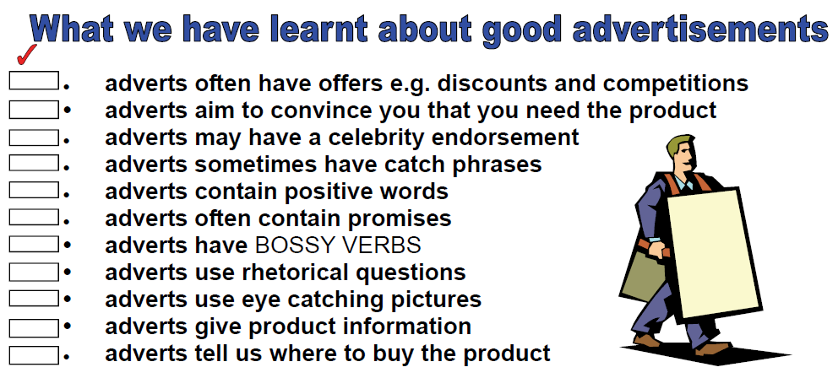

Adverts often have offers – may say that pet comes with a month’s supply of food or something else to encourage someone to buy the pet.

Adverts use persuasive language to make you believe you that buying what ever is for sale, you will be the happiest person on this planet! For example: Buy this talking parrot and you will never be lonely again! I am sure you will come up with something better than this!

Adverts may have an endorsement from someone famous. For example: Corgi puppy for sale; the Queen’s favourite dog.

Adverts may have catch phrases. *For Sale Angel Fish to Make Your Day go Swimmingly*!

--------------------------------------------------------------------------------------------

Now for a bit of fun …have a look at the following adverts, (advertisements) and answer my questions. What is it selling? How does the picture link to what is being sold?



What about this one?

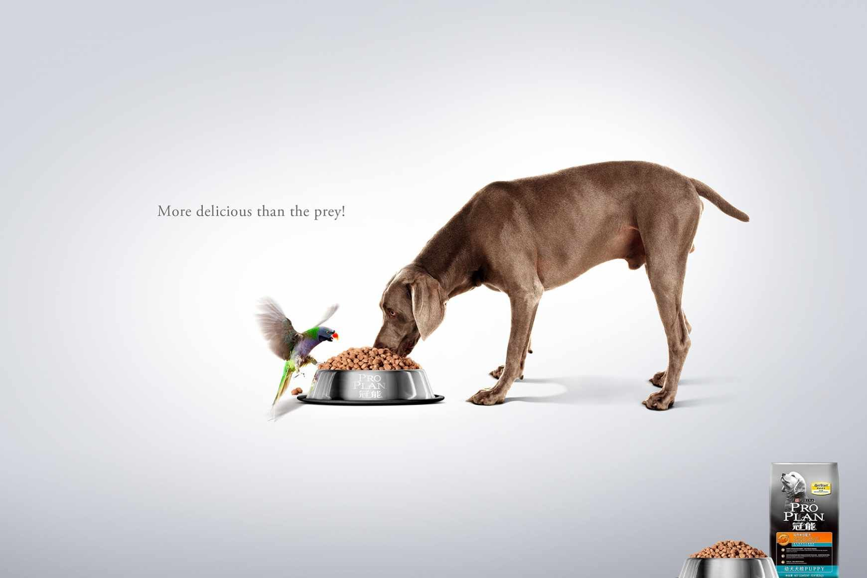

What is clever about this advert?



What is this selling and how do the words fit the picture?

Answers in SeeSaw please.

-------------------------------------------------------------------------------------------

**TASK**: One or two of you have already done this but for those who have not and would like a chance of being on the winners’ board, here we go.

|  |
| --- |
| This Term our writing competition must be about, or include, a rainbow. It can be any genre you that you would like write in. We have had some beautiful poems and imaginative writing submitted in our past competitions and we cannot wait to see what you have in store for us this Term.  [This Photo](https://en.wikipedia.org/wiki/ROYGBIV) by Unknown Author is licensed under [CC BY-SA](https://creativecommons.org/licenses/by-sa/3.0/)  This piece should be done independently where possible – we love seeing the emergent writing of our younger children. Your entries can be photographed and emailed to [jenna.gilfillan@fife.gov.uk](mailto:jenna.gilfillan@fife.gov.uk) or [lucy.kinnear@fife.gov.uk](mailto:lucy.kinnear@fife.gov.uk) by Friday 15th May.  Happy writing 😊 |

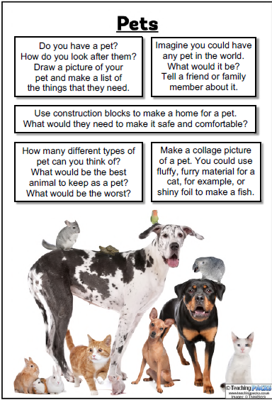**TASK**: All these can be included in your ‘pet project’ and completed whenever you fancy engaging with one. Have fun. Please share on SeeSaw; always love to see your creative work. 😊