Literacy 15.6.20

Spelling

I would like you to complete a chosen chilli challenge for your spelling this week. Use the list of words/word bank in each task as your spelling list for the week.

When you have completed the task, you can practise your spelling words in a way which suits your learning style. Get an adult to test you on the spellings. Ensure that you understand the ‘meaning’ of the word as well as the spelling of the word.

Chilli 1

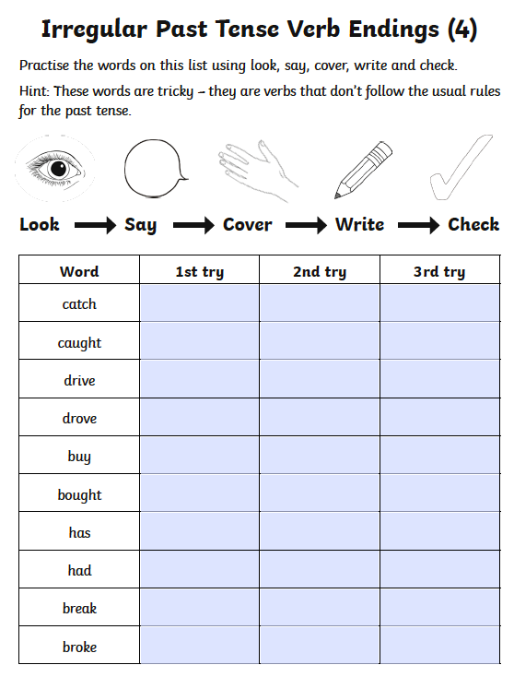

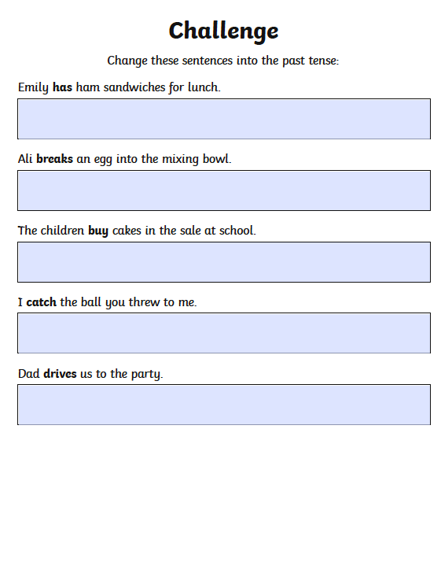

Chilli 2

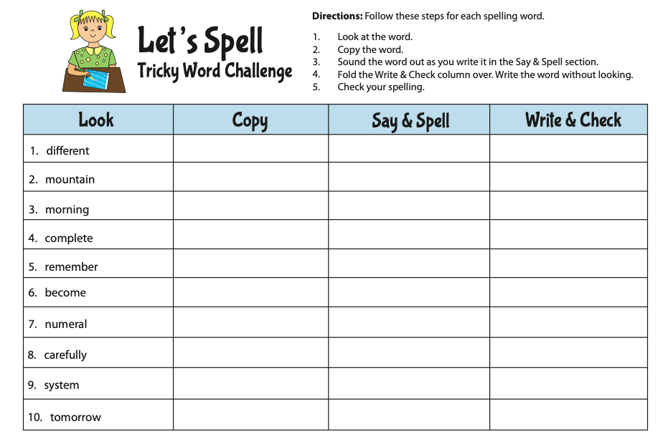

Chilli 3

