**Joke**: Q. What did the computer do at lunchtime? **A: Had a byte to eat!**

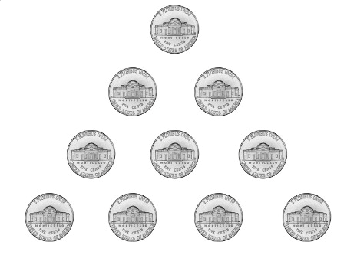

As this is Maths Monday, instead of a riddle, here is your first Maths **task** of the day.

Coin triangle: Move only three coins and turn the triangle upside down. Remember growth mindset.

|  |  |
| --- | --- |
| **Answer to this challenge will be shared later, (if I remember 😉).**  As it important to practise a little maths daily, what follows are a number of links to do just  that. However, if neither appeal, remember you have passwords to SumDog and you know you  can engage with Hit the Button, nrich and Topmarks.  It would great if you could manage to practise your times tables daily and have a go at least  two board sums; four sums using =, -, x and ÷ would be even better. 😊 This should not take  you long and it will be an excellent investment of your time and will serve you well for when  we return to the classroom  **Task:** Below are two links to ‘snappy maths’ which P4 have engaged with before. This is  set up for you to practise your quick recall of the 3-x table and for you to understand the  link between multiplication and division. I have also attached the relevant pages as a PDF.  Why don’t you ask someone to time you to see how long it takes you to do one column?  Then tomorrow try column two and see if you manage it in a quicker time. Ask a family  member to mark your answers. You do not have to share your knowledge of the  3 times table with me. What you can share, if you wish, is how confident you are and  what you will do if you are not.  <http://www.snappymaths.com/multdiv/3xtable/resources/3xtablemmmab.pdf>  <http://www.snappymaths.com/multdiv/3xtable/resources/3xdivmmmab.pdf> |  |

**Task:** Links are to Bitesize daily lessons. These two links take you straight to the learning pages. The first link is targeted at P4, whilst the second link, P5. Today’s lesson is about adding 3- or 4-digit numbers together.

<https://www.bbc.co.uk/bitesize/articles/z72dwty>

<https://www.bbc.co.uk/bitesize/articles/z6vr47h>

**Task:** Topic related. It would really help if you could do this task with the help of an older sibling or another family member. There is also a wealth of support clips on offer through YouTube if stuck or just need a little extra support. Just make sure that what you are watching is suitable and an adult has checked this first. This task, is worth taking your time over. Please do not rush. It then will be a very good piece of work to include into your pets’ project. Thank you. 😊

You are going to use your measuring skills to draw to scale, the accommodation your pet will need. You can also use your knowledge of shapes and angles. (See the ‘properties of shapes’ mat and sent you last week; it should help.) For example:

* 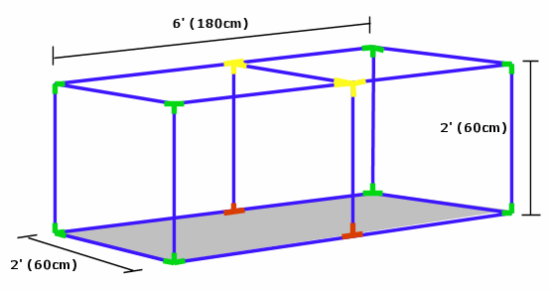some pets will need a hutch
* dog – well, let’s pretend a kennel
* fish, a tank
* horse, a stable
* bird, a cage
* hen, a coop
* 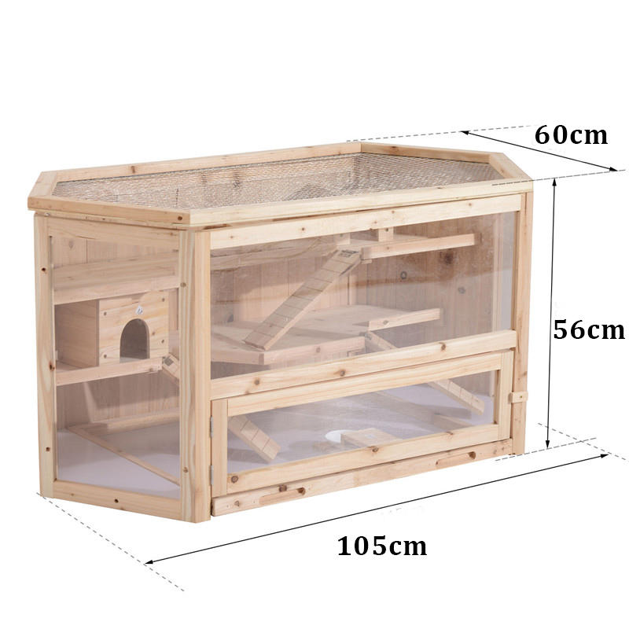hamster, mice, rats and the like, a cage

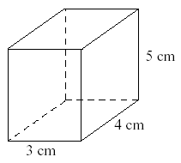

**Fish tank**:

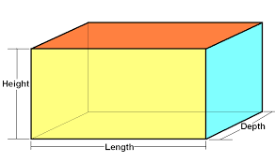Shapes are all around us. Most pet cages/hutches/tanks etc. will feature a cuboid. So, if you draw and measure this, then you are more than half-way there. Everyone should have a ruler because we sorted this in class that last week. However, if you do not, use something else like Lego bricks. You could say that the length of the hutch is 10 Lego bricks and each Lego brick will represent 15 cm.

|  |
| --- |
| **This is an excellent and easy to understand clip on how to understand scale. It is American site, so please note that we spell centimetres and metres slightly different. Thank you.**  <https://www.khanacademy.org/math/cc-seventh-grade-math/cc-7th-geometry/cc-7th-scale-drawings/v/scaled-drawings-worked-examples> |

I do appreciate that this may be quite a challenge, so here are two manageable ideas as to how to do this if the above is too confusing.

1. Ask someone in your family to draw the accommodation your pet will need. Then, using your ruler, you add in the dimensions (length of the lines). You can round the measurements to the nearest cm.
2. If you have a printer, print off a hutch and just add in the measurements. Something like this:

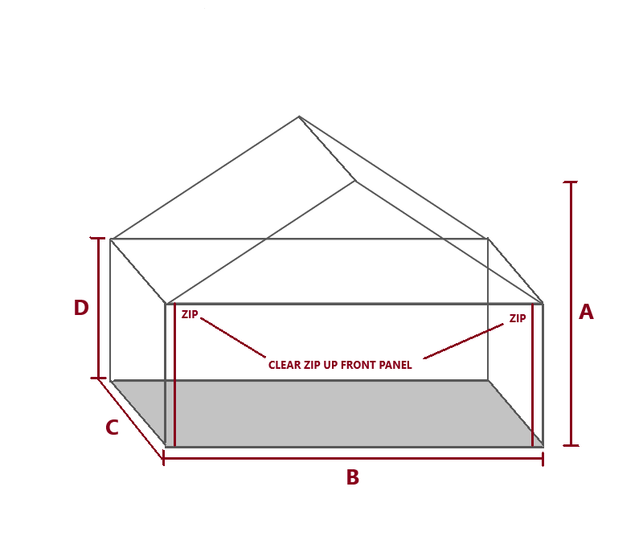Then can you think of a sensible scale?

Go on! Believe in yourself; I do. You can do this and just think when you have finished, how chuffed you will be with your understanding. Thank you for engaging with this very worthwhile task. 😊

**Task**: Share your answer in SeeSaw this way. Missing pyramid number is ____.

