Times Tables Tuesday

**Hi Primary 5,**

**Today your maths task is to practise your times tables by playing a game. You may wish to use an online game of your choosing, or you could play one of these games:**

Multiplication War

Play multiplication war with a deck of cards. Just flip two cards and multiply. Whoever has the highest product keeps the cards. The player with the most cards wins.

Rock, Paper, Scissors

Put up fingers instead of rock, paper, or scissors. The first person to multiply the two sets of fingers together and call out the product (answer) gets a point.

Arrays

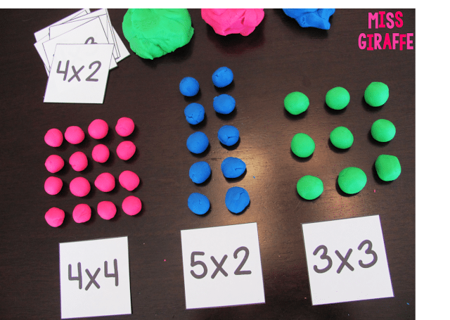An array is a systematic arrangement of similar objects, usually in rows and columns. Using unusual objects helps the concept stick. Fun ideas to try: paper clips, pretzels, M&Ms, crayons, tiles, blocks, buttons, popcorn kernels, rice, washers, chocolate chips, pom-poms, cheese balls, jewels, Smarties, pennies, raisins, pistachios, lentils, counters, or LEGO bricks.

Make a Multiplication Problem Generator

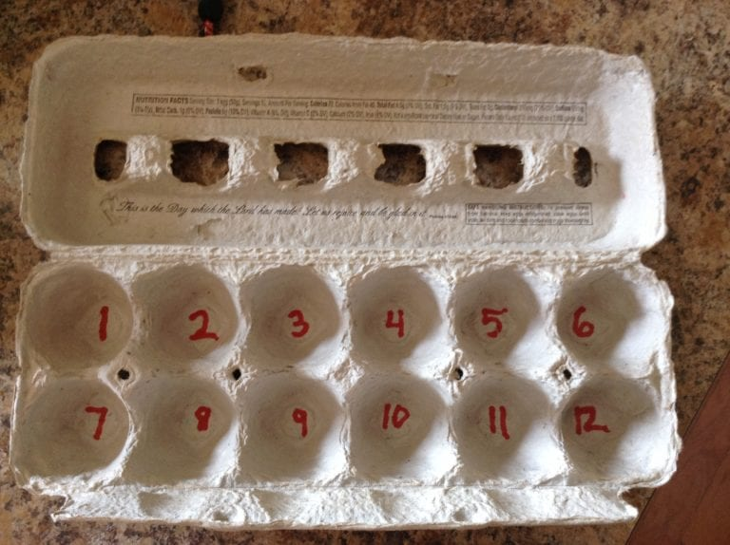Use an egg carton and write a number in the bottom of each depression. Put two marbles inside. Students shake the egg carton, open the top, and whatever two numbers the marbles have landed on, they multiply together. Play alone or with a buddy.

You might also wish to try this…

Videos

Search for multiplication [sing-along videos](http://bit.ly/1kTMwoE) and sing your way to multiplication mastery!