**Writing on Wednesday and other learning opportunities**

**Today’s date is Wednesday, 20th May 2020.**

**TASK**: Look up the word ‘persuade’. Record the definition in SeeSaw. Thank you.

**TASK**: Oh, my goodness! You have lost your pet or your pet has gone missing! Design a poster which will help get you and your pet reunited. I have sent a couple of PDF templates, although I think you will manage this task very well using your own initiative. Remember to include all the relevant information, a picture/photograph, correct spelling and maybe you might like to offer a reward? What would you give someone if they found your lost pet?

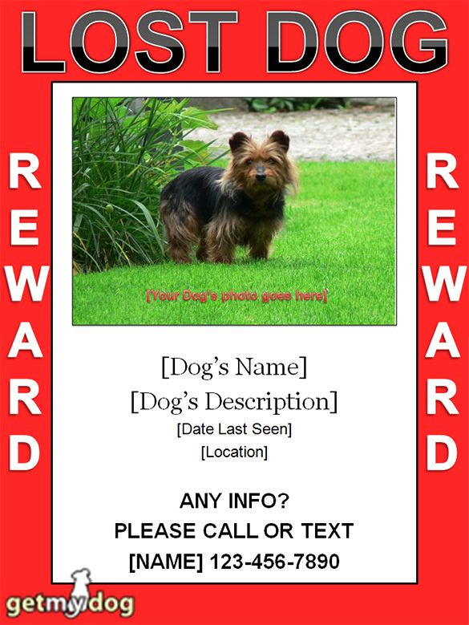Possible information to include. Example of a ‘lost cat’ poster.

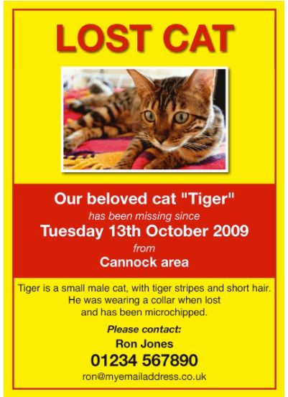

**TASK**: New learning – the ‘art of persuasion’.

Watch all three short clips, as these will support your understanding of what is to follow.

<https://www.youtube.com/watch?v=hD9arWXIddM>

<https://www.youtube.com/watch?v=yiexHnX0xZY>

<https://www.youtube.com/watch?v=nHCYvNvV68c>

|  |
| --- |
| Persuasive writing is a type of writing in which someone tries to get the reader to agree with their opinion or ideas. Knowing how to write persuasively and learning how to recognise persuasive writing are valuable skills for children to learn. |

|  |
| --- |
| 1. We should not have to wear school uniform. 2. Pets should be allowed in school. 3. School break times should be longer. (In America they call it ‘recess’) 4. There should be no homework. 5. The school day should be shorter. 6. I should get pocket money. 7. I should be able to go to bed later. 8. I should be allowed to have a pet (or another pet!). 9. Everyone should have to exercise every day. 10. We should all grow our own vegetables. 11. **OR YOUR OWN CHOICE.** |

Steps for Success:

1. Watch all three, short clips – perhaps you may want to watch the last clip again when you begin to work on your draft.
2. From the list above, choose one writing prompt about something you want to persuade someone to agree with or do.
3. Write a rough draft, (plan) including a closing paragraph.
4. Check over your draft – tweak if necessary.
5. Remember you want the reader to agree with you, so use persuasive words and phrases such as those listed below and/or suggested in the clips:

|  |  |  |  |  |
| --- | --- | --- | --- | --- |
| Some people believe that  In my opinion | Therefore  For this reason | I feel that  I am sure that | Surely  It is certain | firstly, and  secondly… |

1. To help convince the reader, give them some facts. This will help convince the reader to agree with your point of view.
2. Ask your reader questions as this will get them thinking.

|  |
| --- |
| I am asking you to go NO further. Leave your writing at the draft stage. This will be completed TOMORROW. |

**TASK**: Can you unscramble these anagrams of various mammals? Share your answers through SeeSaw in any format you wish. I am looking for correct spelling!



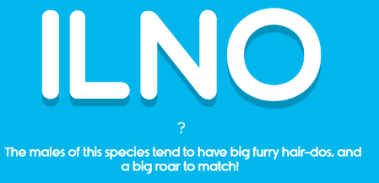



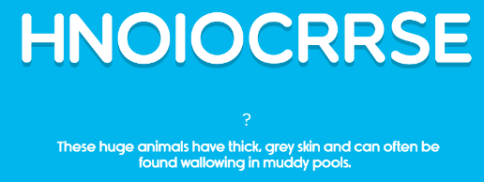

**TASK**: **Wednesday’s Maths Tasks:** Engage with as little or as much as you think **YOU** need to support your numeracy and maths progress.

😊 Times Tables Practice – focus on the one you are least confident with. (Hit the Button/Snappy Maths etc.)

😊 10 minutes SumDog.

😊 Number stories – add and subtraction sums using **ONLY** these

three numbers 23, 109, 86

😊 Maths crossword puzzle – PDF

😊 Daily Challenge - PDF

|  |
| --- |
| Please remember to share or at least think about WWW and NS. If there is anything, I can support you with, PLEASE ask. |

**Health and Wellbeing**

**TASK**: The term ‘Life Skills’ refers to skills you need to make the most out of life. Any skill that is useful in your life can be considered a life skill. Tying your shoelaces, swimming, crossing the road, using a computer, driving a car are, for most people, useful life skills. We need these life skills to cope with our lives effectively and deal with the challenges we face, whatever our age.

So, t**o make this fun for you, I have found a 30-day Kids Life Skills Challenge. (PDF)**

**Colour or tick off the daily challenges as you do them. I don’t think it matters what order you do them in; just what suits you. Enjoy.** 😊

**TASK**: I Can Grow My Own Brain – see PDF. You will enjoy this one, especially if you are in the right frame of mind! 😉