

Good Morning Primary 5,

Welcome to another week of Home Learning and Maths Monday 😊.

This week is our final week of learning about fractions. We will be moving on to a new Maths topic next week but remember that if you think you need more practise, you can always look back over the fractions tasks at any time.

Please find below the three Chilli Challenges for this week. Two are finishing off fractions work and the third Chilli Challenge is all about multiplication, focusing on the 9 times table.



**I am learning to estimate position of a sequence of fractions on a number line including beyond a whole.**

You may want to watch the following video, to help your understanding when thinking about fractions on a number line.

<https://www.bing.com/videos/search?q=khan+academy+fractions+on+number+line&docid=608000367574450551&mid=DFD7B93E8B22FC793A29DFD7B93E8B22FC793A29&view=detail&FORM=VIRE>

Also, remember that you might need to simplify some of these fractions once you have figured out the correct answer.



**I am learning to use materials to show that for example, 3 divided by 4 = ¾ and generalise for other fractions.**

Watch the following video:

<https://www.khanacademy.org/math/arithmetic/fraction-arithmetic/arith-review-fractions-as-division/v/fractions-as-division>

Can you think of five examples of your own to show how fractions and division are linked? What materials can you use to show your thinking?



**I am learning about multiplication and the 9 times table.**

I understand from Mrs Innes that you have not yet learned about the 9 times table. For today’s challenge I would like you to look at the following hints and tips about learning your 9 times table and think about which method helps you the most. Once you have decided which once is most helpful to you, think about why that is and why that works best for your brain and the way you think. Please write down your choice and your reasons and post to TEAMS.

Perhaps you do not really like any of the suggestions. In that case, can you think of any other ways you could learn your 9 times table? Again, explain why you prefer your chosen method.

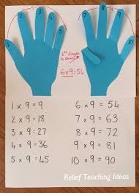This method uses your fingers to help you work out the answer. So, if you want to know 6 x 9, you hold down your 6th finger and all the fingers before it make the tens and all the fingers after make the ones, so the answer is 54.

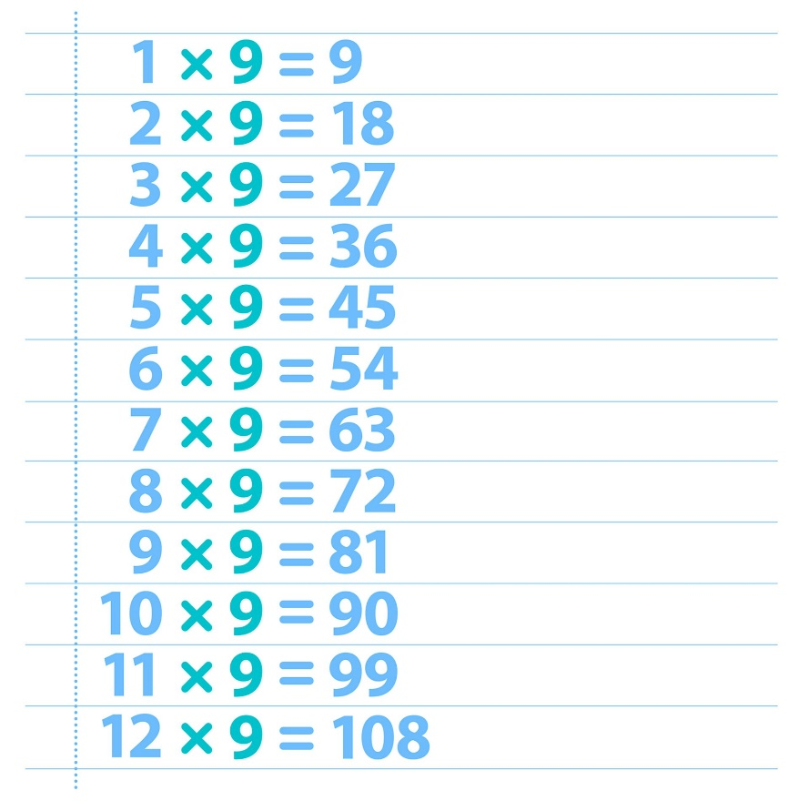With this method, if you write out your nine times table you will see that each answer increases by one ten every time and the ones decrease by one digit every time.

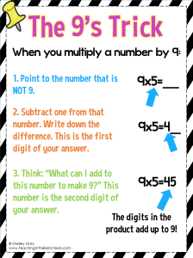This method uses your knowledge of number bonds to 9 to help you check your answer.

These are just a few examples. Can you think of any others? Could you use your knowledge of the 10 times table to help you figure out the 9 times table?