**How Big Are Classes 5, 6 and 7?**

**Age 7 to 11**

Class 4 were making graphs. Ben, Ali, Katie and Charlene decided to make graphs of the sizes of the seven classes in the school.

They went to the office to collect the numbers of children in all the other classes. Ben and Ali wrote down the numbers for Classes 1, 2 and 3. Katie and Charlene wrote down the numbers for Classes 5,6 and 7. Of course they all knew the number of children in Class 4.

Ben and Ali drew a block graph. It looked like this:

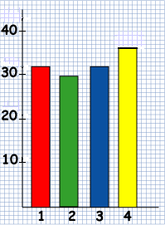

Katie and Charlene decided to make theirs differently. They drew this graph:

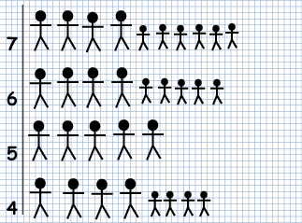

Miss Brown came along to look at their work.

"It's an interesting graph," she said, "but it's difficult to tell how many children are in each class. Please can you make a scale on it so we can all read it?"

Katie and Charlene did what they were told.

How many children were there altogether in Classes 5,6 and 7?