Build a marble run  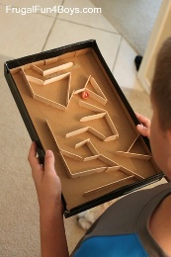 | The task  Use any materials you have at home to create a marble run game. It could be made from junk modelling, pencils, paper, lollypop sticks, Lego, sticks and stones, whatever you can get your hands on. As long as you can place a marble at the tops and it rolls to the bottom, you have done it!  https://www.hellowonderful.co/post/15-impressive-ways-to-make-a-marble-run/ | Extension challenge  Make a marble run where the marble has to travel for at least 1 metre.
A playing cards tower  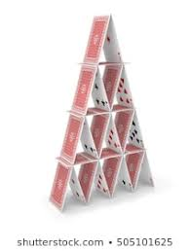 | The Task  Use as many playing cards as you can to make a tower out of playing cards. Measure how high you were able to get the tower without them falling down. | Extension Challenge  Make a structure out of playing cards that is not a pyramid. Use the cards in a different way to build a tower.
Build a raft that floats  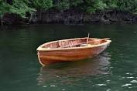 | The task  Use anything you have around the house to build a raft that will successfully float in water. How many 1 pence coins can it hold before it begins to sink?  https://www.pinterest.co.uk/pin/25684660352135326/ | Extension challenge  Add a sail to your raft which makes the raft speed up in the wind.

