**Li: To up level sentences**

**You can up level these explanations by using ambitious vocabulary, VCOP and by extending each sentence to make them more interesting. Remember to use online tools such as an online thesaurus to up level the vocabulary already used! You should have used this within your writing task yesterday ☺.**

1. It was a hot day. The beach was hot and the sky was blue. The palm trees swayed in the wind. The sea lapped the shore. The sand felt nice.

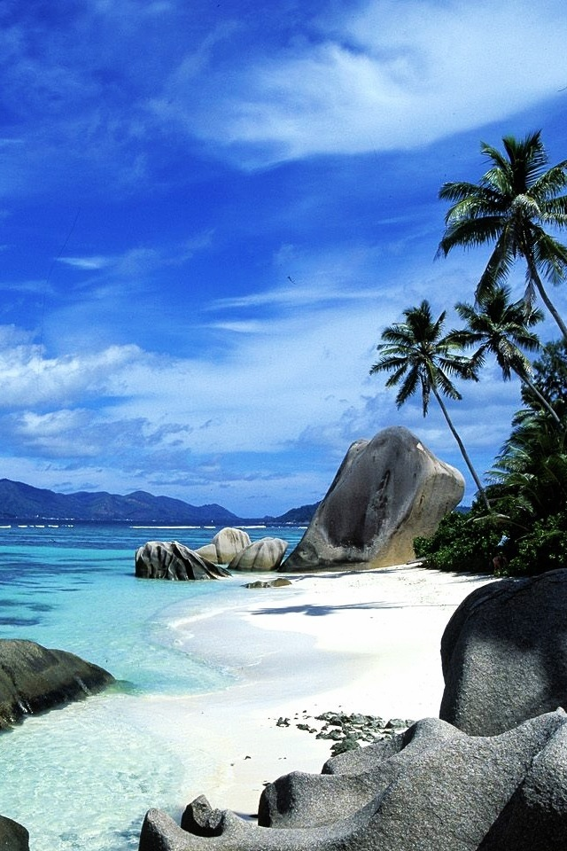

1. The arch was covered in snow. It was cold. There was lots of ice and snow.

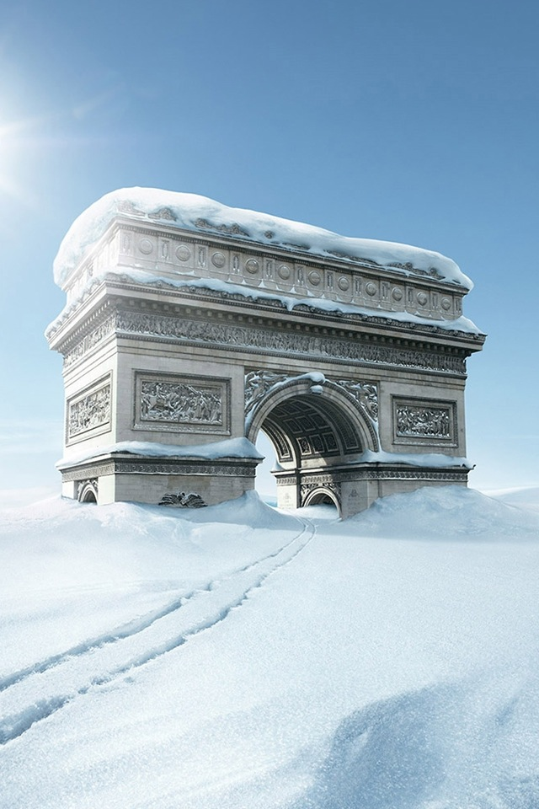

1. The cave smelt dirty. The water was blue and there was sun coming down. It was a bit scary.

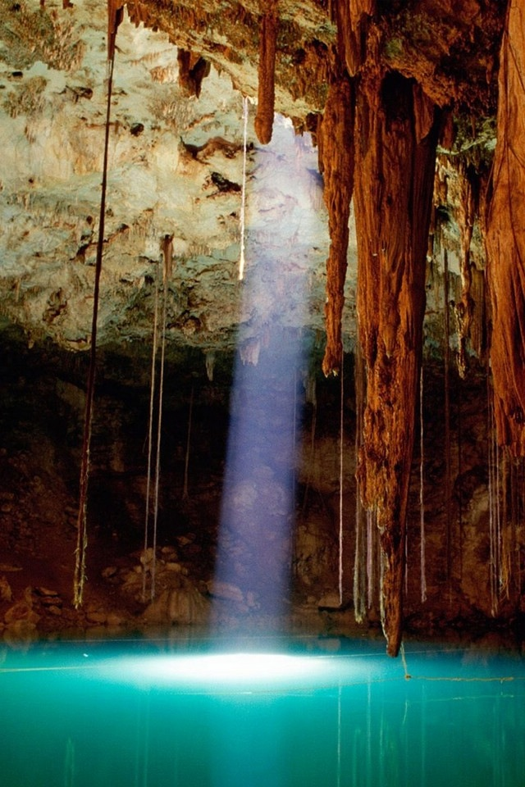

1. There were lots of leaves and bushes. They were covering the wall. In the wall there was a door made from wood and there was a gate in front of it.

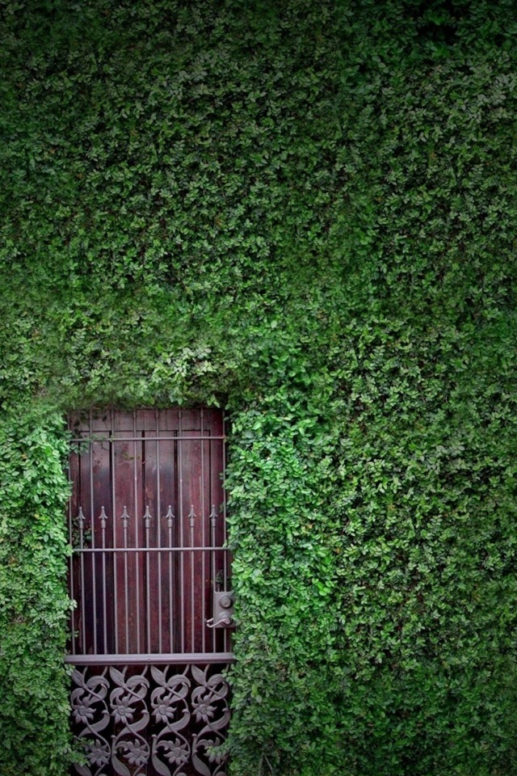

1. It was warm water and there were lots of colourful fish swimming around.

