Word Doc

**Literacy for Thursday** – 7th May 2020

|  |
| --- |
| **Joke**: Q: Where did the school kittens go for their field trip? **A: To the ‘mewseum’!**  brain-teasers-for-kids-with-answers**Spot the Difference:** |

Good morning, today will have a few tasks attributed to literacy and language but as tomorrow is VE Day, I am going to focus more on this. I hope that is ok?

**TASK**: I do not mind how much or how little of this poem you write, as long as take this opportunity to practise your cursive handwriting. 😊 This can be added to your pet project too. In fact, any of your learning which has a focus on pets can be included. If you think back to what IDL means, then including all areas of learning makes sense.

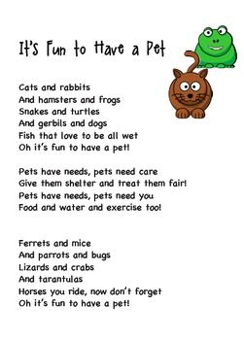

**Revision TASK**: As you know Mrs. Logan has gone over this area of learning many times but for some of you the apostrophe still causes confusion. Below are three links; all explain how the apostrophe is used but in a star, rated order. For example, for those who have a good understanding of the use of the apostrophe, then follow the link with ***. However, you can watch al three if you wish – the first one is in song form! 😊

* <https://www.youtube.com/watch?v=B4MVPA1xCY0>

** <https://www.youtube.com/watch?v=pHzKfb8TjSw>

*** <https://www.youtube.com/watch?v=My6oGvkHnfY>

**Once you think you have got it, have a go at the SeeSaw activity.**

As you know, the origin of words, (e**tymology)** fascinates me and because I like to share what little bits of knowledge I have, when I can, here is today’s:

|  |
| --- |
| The word apostrophe comes from the Greek word apóstrophos which refers to a mark used in Greek to signify an omitted letter. It literally means a ‘mark of turning away’. |

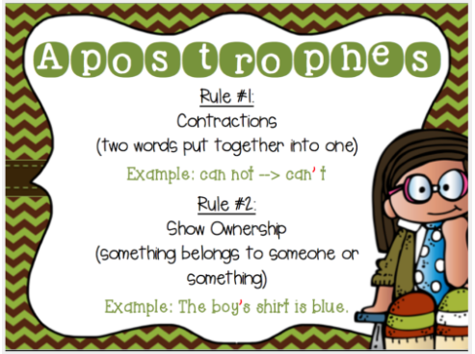

**New Learning TASK**: Today we are going to be learning how to use speech marks correctly. Sometimes, people refer to speech marks, as quotation marks. For the purpose of our learning, we will call them speech marks.

I think some of you will find this piece of learning easier to grasp than the apostrophe, which a few must think, it’s all a bit Greek! 😉

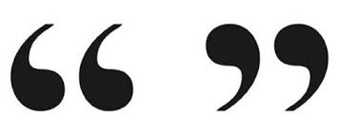This what speech marks look like – sometimes they are referred to as ’66 and 99’ because they resemble these numbers.

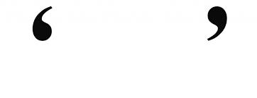

Can I also point out, that in most reading books, the speech marks appear as single punctuation marks like this?

* Firstly, to help with your understanding, watch this clip: <https://www.youtube.com/watch?v=wSu9n6VdE-s>
* Then, once you think you have got it, have a go at the SeeSaw activity.
* Lastly, look through your reading book and find the parts with speech. Copy out a sentence or two accurately. Check that you have used your ‘steps for success checklist of questions’.

|  |
| --- |
| **1.** Do you have speech marks at the start and at the end of what is being spoken?  e.g. “Yes,” said Fred.  **2.** Do you have a capital letter at the start of the speech?  e.g. “Yes,” said Fred.  **3.** Do you have your punctuation inside the speech marks?  e.g. “Hooray!” said Fred.  **4.** Have you remembered a new line for each new speaker?  e.g. 1st speaker: “What time is it?” asked Michael.  New speaker so new line: “It’s ten past eight,” replied his Mum.  **5.** Have you remembered those commas? Look at these two examples and work out how the comma has been used in each.  Michael whispered, “Let’s go.” Before the 1st speech mark.  “Let’s go,” whispered Michael. Before the last speech mark. |

-------------------------------------------------------

|  |
| --- |
| The 75th Anniversary of VE Day This Friday, 8th May, will mark 75 years since the end of World War II in Europe. All sorts of activities had been planned for the occasion - including the moving of our traditional May bank holiday - but of course circumstances have changed and we will all now be staying at home.   Yet, that doesn't mean that you can't decorate your houses, learn a little about VE Day, say thank you to those who made peace possible and plan your own celebrations! I have all sorts of ideas and resources to make the day fun, which I will be sharing with you. |

**TASK**: What does VE Day mean?

**TASK**: Who is known as the *‘Forces Sweetheart’?*

**TASK**: Today’s comprehension focuses on VE Day and once again the passages are differentiated. (Sent as PDF via the App. and SeeSaw.) If you do not wish to engage with the comprehension, could I ask you very nicely to at least read one of the passages or have it read to you? That would really make my day. Many thanks. 😊

---------------------------------------------------------------------------

**Extra Fun Tasks**!

I do not have any neighbours to join in the fun with me but I will be making some bunting and will be honouring this day in the best way I can. I am sure Tash will join in some of the fun too!

If you follow this link, you can make your own bunting.

<https://www.bbc.co.uk/programmes/articles/4TrqYDyf4PMdLypxzyTwGDg/great-british-bunting>

I was thinking that if everyone took a photograph of just **one** of your bunting’s triangles and popped them on SeeSaw, I could share them; like I did when we all drank tea together. Just an idea – I know, sometimes I get carried away on a wave of enthusiasm! 😊

However, one thing I will most definitely be doing and it’s probably just as well I do not have any neighbours, is this: **Ain Lyrics – VE Day Singalong**



As part of the VE Day 75th Anniversary celebrations, on Friday 8th May the nation is invited to sing along to a rendition of We’ll Meet Again at 9pm, just after an address from Her Majesty the Queen.

If you would like to sing along, here is a link to the song:

<https://www.bbc.co.uk/programmes/articles/5qhhFG1vNtX8swrtg9gKQlR/we-ll-meet-again-lyrics-ve-day-singalong>

VE Day fun activities for you to dip in and out of if you fancy.

<https://www.thebritishschool.co.uk/ve-day-activities/>

I have also sent a VE Day PDF which has a few more ideas; some similar, some different and if anyone fancies getting involved in a virtual tea party, well just follow the website on this poster!



So, until we ‘meet again’, have the most possible fun you can manage … enjoy the Bank Holiday weekend and I’ll be back on Monday! Keep safe and smiling. Bye for now,

Mrs. Logan xx