



Addition and Subtraction with carrying and exchanging

1. Up to 20

1. Up to 100

1. Beyond 100



Multiplication and Division using times tables or a times table square

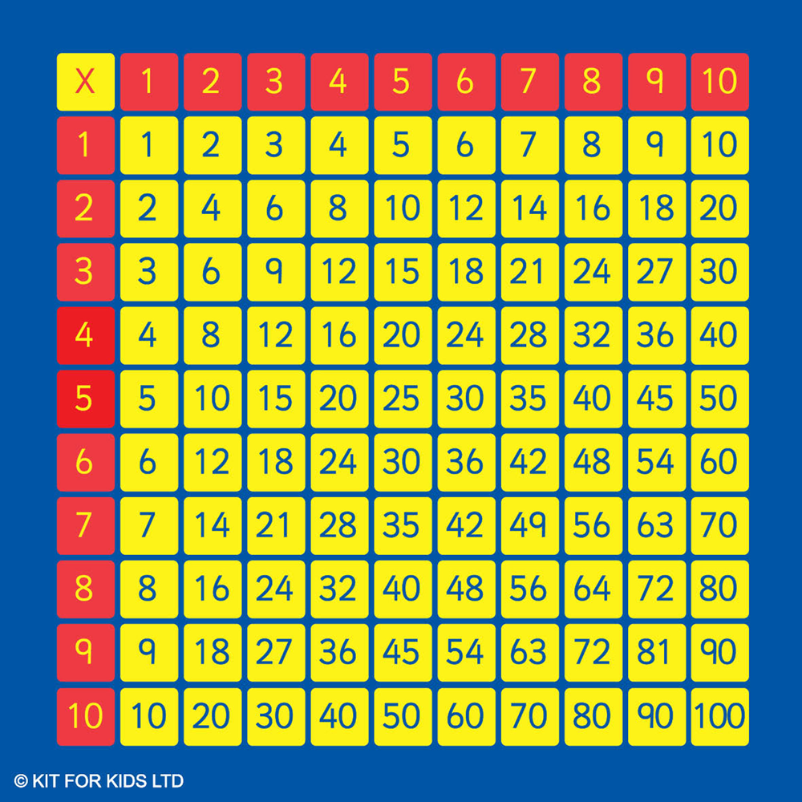



Multiplication and Division using fact family knowledge

<https://www.topmarks.co.uk/number-facts/number-fact-families>

Extra Challenge

<https://www.timestables.com/9-times-table.html>