Chilli Challenge

Today we are learning that fractions are linked to wholes and we will be thinking about what materials we can use and diagrams we can draw to represent fractions of wholes.

The activity below shows a selection of wholes, that is the whole shape. You need to colour in the fraction of the shape that is noted at the top of each diagram.

Extension Activity: Can you think of anything you might have at home that you could use, instead of paper and pen, to show these same fractions of a whole? Do not worry about copying the shapes exactly, think about wholes and fractions. You might use food, toys or nature.

This second activity shows the fraction of the whole already shaded. Can you figure out what fraction of the whole is coloured?

Extension Activity: what words were you using to help figure out the fraction? For example, did you use words like parts of, divided by or sections?



Task 1

Today we are learning how to use our understanding of modelling and drawing to write equivalent fractions.

After looking at last week’s work, I can see that you are all good at drawing a whole and splitting it into parts to be able to work out a fraction of the whole and then write it down. This week I would like to extend your thinking about the types of modelling and drawing you could use to represent a whole and the fraction of the whole.

I have written 10 questions below. Can you find an equivalent fraction for each one? Of course, you can! But I would like you to have a look around your home and garden to see what objects you can find to represent these equivalent fractions. Here is an example:

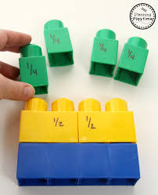

You can see from the picture that by using the Mega Blocks, we can show how 1/2 is the same as 2/4.

Try to find as many different objects as you can. If you can find a different object for each question, I will be very impressed!

|  |  |  |  |
| --- | --- | --- | --- |
| 1. 15   20 | 1. 7   14 | 1. 9   12 | 1. 5   10 |
| 1. 6   18 | 1. 2   10 | 1. 2   4 | 1. 4   6 |
| 1. 3   9 | 1. 6   9 |  |  |

Extension Activity: Can you use the objects you have used in the above task to create some of your own questions? How many parts can you divide your whole into to show some interesting equivalent fractions?

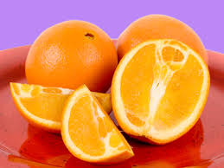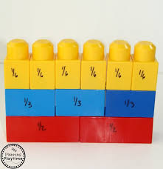 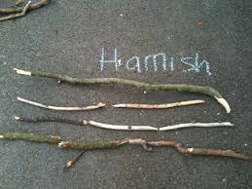



We are learning how to write addition sums and subtraction calculations using fractions.

Adding fractions may be completely new to you, or you may need to refresh your skills from last year. If so, here is a video for you to watch which explains how to add fractions with the same denominator.

Task 1

<https://www.khanacademy.org/math/arithmetic/fraction-arithmetic/arith-review-adding-subtracting-frac/v/adding-fractions-with-like-denominators>

Here are some adding sums for you to try. They all use the same denominator, so remember what you have already learned about equivalent fractions and see if you can simplify any of your answers using your timetables knowledge. A screenshot of a cell phone

Extension Activity: These questions have the answers, but part of the sum is missing. Can you work out the missing fraction? Remember that the fractions will have the same denominator in the sum. The answer may show an equivalent fraction.

Task 2

Now on to subtracting fractions with the same denominator. Like with adding, you may need to simplify the answer by using your knowledge of timetables to find an equivalent fraction. If you think you might need further help, here is another useful video.

<https://www.khanacademy.org/math/arithmetic/fraction-arithmetic/arith-review-adding-subtracting-frac/v/subtracting-fractions>

Extension Activity: Can you complete the subtraction calculations by finding the missing fraction? Again, remember that you may need to simplify your answer by finding an equivalent fraction.

