Word document.

**Writing for Wednesday** – 6th May 2020

|  |
| --- |
| **Joke**: Q. What happened when the teacher tied all the kids shoe laces together? **A. They had a class trip!**  **Riddle: Q.**What occurs twice in a week, once in a year but never in a day? **A. The letter E.** |

Morning wonderful-Wednesday-writers! Some of today’s writing tasks will be just right to include in your pet projects. I think by now your project will be beginning to bulge just like the cheeks of a pet hamster! I am excited to see them. 😊

Well, Primary 4, as you know that over the course of Terms 1, 2 1nd 3 we investigated a variety of poems. You wrote acrostic poems, haikus, cinquains and others which rhymed. Each time you wrote a poem, you thought about writing techniques like some of the ones displayed on this poster. (This will be sent to you through SeeSaw.)

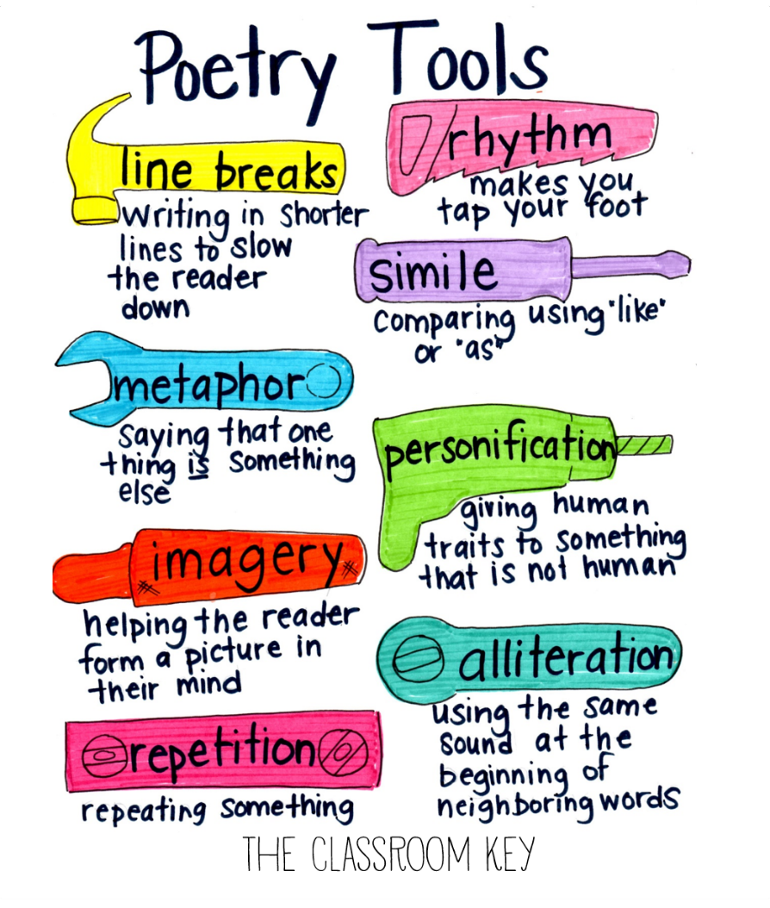

**TASK**: Write a review for just one of the following poems. Remember, a review is just your opinion of whether you like or do not like something. However, your review of the poem needs to be supported by good reasons why you liked or do not like it.

Things to consider:

* What did you like/not like about the poem– why?
* What words were used that helped you come to your decision?
* How does the poem make you feel? Why?
* Would you recommend this poem to other children? Why?
* Would it be possible to draw a picture to go with this poem? Why?

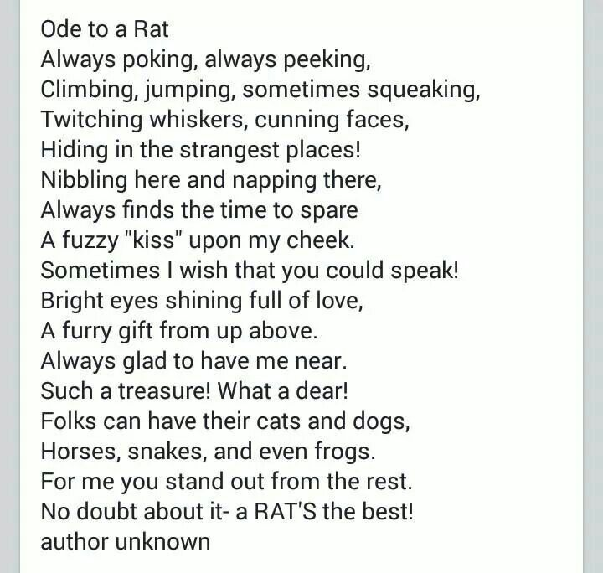

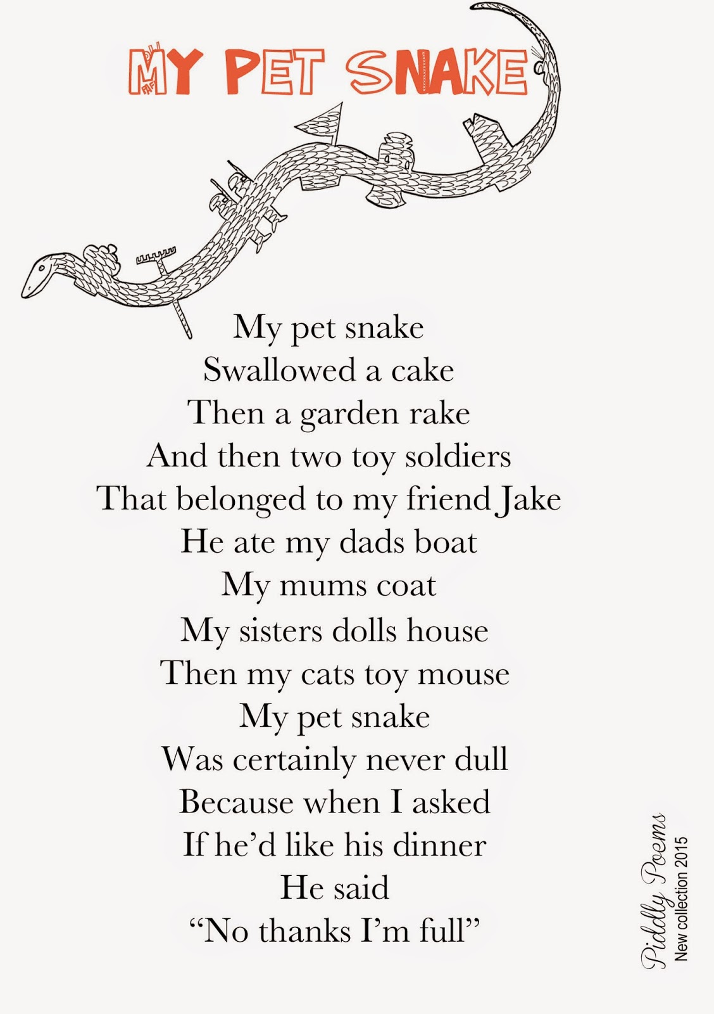

This is a shape poem and needs to be read right across the page – left to right as we would normally read!

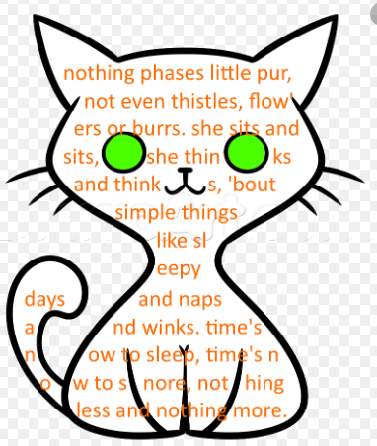

**----------------------------------------------------**

**TASK**: Today you are going to learn what a limerick is and to have a go at writing your own; don’t forget to illustrate it too! 😉 Once you have watched the YouTube clip, read the Limericks below and the checklist, you will know what your steps for success will be. I am beginning to giggle when I imagine how funny some of yours will be! Good luck.

**YouTube clip**: <https://youtu.be/Wy65TkCadfU>

Examples of Limericks:

|  |
| --- |
| There was a young mutt from Yeppoon  Who set out from home in mid-June  In a home crafted rocket  The size of a pocket  He became the First Dog on the Moon! |

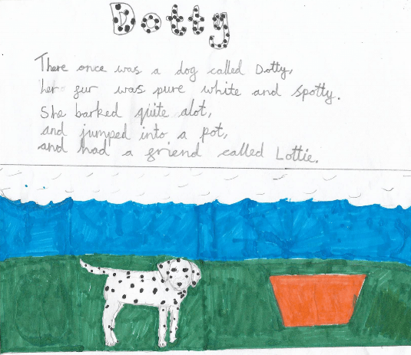

|  |
| --- |
| There once was a mucky, smelly cat, Who wore a dirty, grubby hat, It blew in the wind, To the tree it got pinned, And now the hat is owned by a bat! |

|  |
| --- |
| What are Limericks?    Here is a reminder of the rhyming pattern: |

**-----------------------------------------------------**

**TASK**: Here there is a choice to either design a menu for your pet or produce a fact file, (of course, there is nothing to stop you doing both if you wish 😊).

Below are examples for both but you can design your own; let your creativity capture your imagination! The only requirement is that all the **foods** you show on your menu have to be foods that **your pet can eat**, (part of their healthy diet).



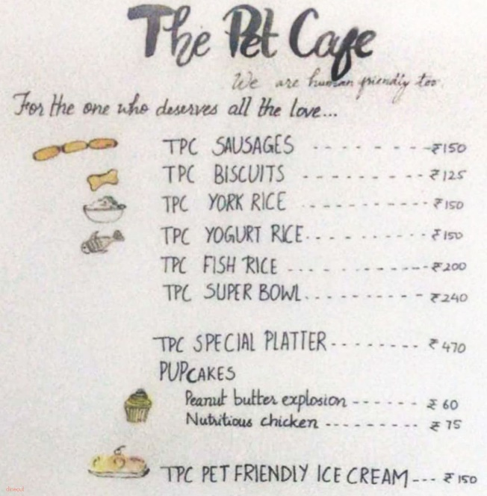

**OR** you could make a fact sheet – it does not have to be like the example on the next page; feel free to design your own. The example I have included is a fact sheet for a parrot and was taken from PMFA site I shared with you yesterday. Here is the link which will take you to the fact sheet page for small mammals but the rhs menu links to factsheets for other pets. I hope it helps.

<https://www.pfma.org.uk/small-mammals-fact-sheet>

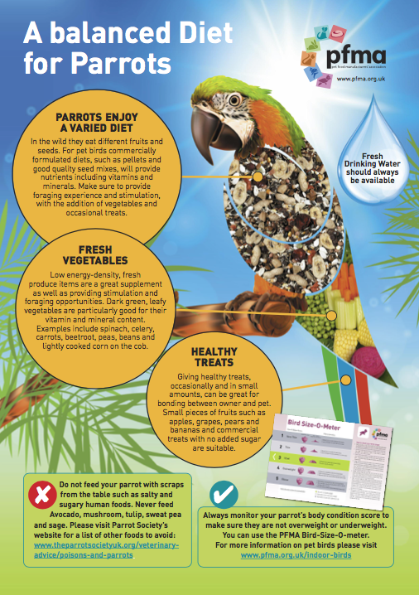

Here are two more links curtesy of Emma.

**TASK**: Follow the link and learn the dance! I love the music and when I was having a go, it really lifted my spirits! I have much respect for Gurdeep Pandher.

**Dance to be Happy and Active:** [**https://youtu.be/kNWQsmnlmI4**](https://youtu.be/kNWQsmnlmI4)

|  |
| --- |
| Gurdeep lives in Canada but can you find out when he moved here and where he was living before?  Looking forward to seeing some of your bhangra dancing – please share on SeeSaw. Perhaps, get ALL your family up and dancing. Let’s have some fun. 😊 |

This second link is purely to inspire. Watching para athletes always leaves me in awe.

* Para athletes exercising at home: <https://youtu.be/Eb1DGcS0n_c>

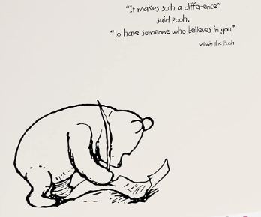

Enjoy this Wednesday … it’s here especially for you. 😊