HOW TO MAKE DOCUMENTS ‘SPEAK TO YOU’

On a Mac

Open a Word Document

Type your text.

Go to ‘Review’ along the top toolbar.

Click on ‘Read Aloud’. A small box will appear

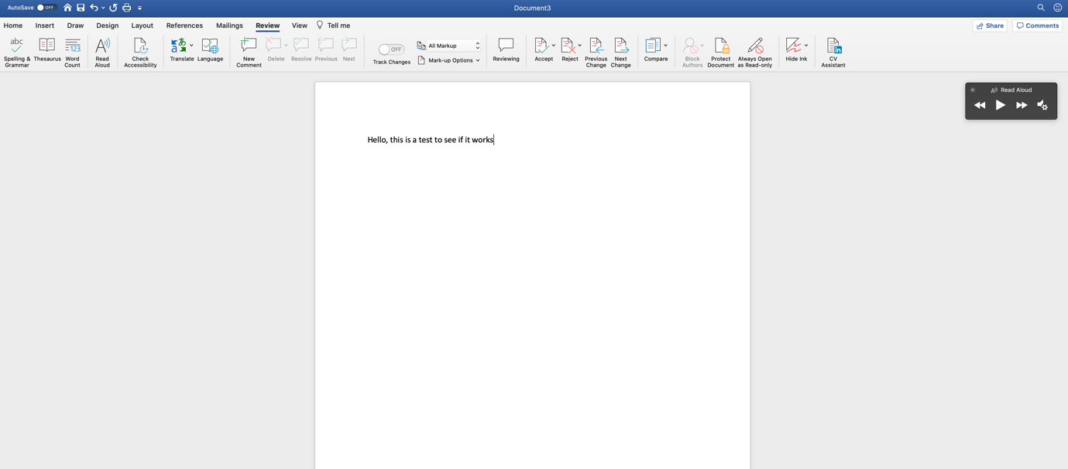

Highlight the text you want to be read out.

Click on the ‘play’ symbol.

The text will be read to you.

On a PC (Word 2016)

Follow the instructions from here…

https://www.youtube.com/watch?v=Juoc4-3b_dw

On an Ipad / Iphone

Go to ‘Settings’

Go to ‘Accessibility’

Click on ‘Spoken Content’
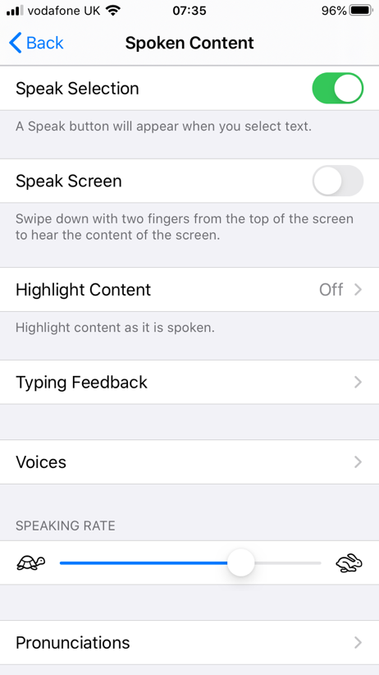

Switch ‘Speak Selection’ to ‘On’

Here you can choose which voice you would like

Here you can slow down or speed up the speech

Now, when you highlight text, a ‘speak’ button will appear

PDF Documents

Adobe Reader has a built-in text reader – Read Out Loud. This reads aloud text on a PDF using the computer’s voice.

On a PDF Document on a PC go to:

View Read Out Loud Activate Read Out Loud

You can choose a voice by going to

Edit Preferences Reading (from the left pane) untick Use Default Voice (choose a voice) OK.

On a PDF Document on a Mac

Highlight the text you wish to be read out

Go to Edit Speech Start Speaking

