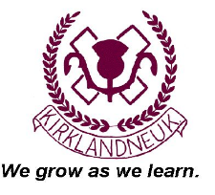
*Friendly*Nurturing*High Expectations*Open Forum*
Valued*Respected*Community*
Kirklandneuk Primary School
Ard Road, Renfrew, PA4 9DA
Tel: 0300 3000 164
Head Teacher: Karen Logue

January 2020

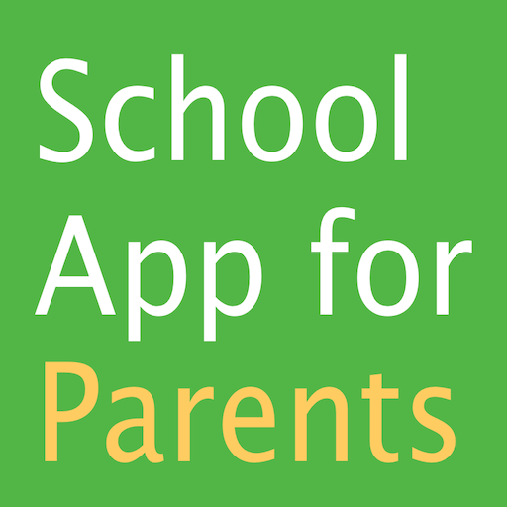
Dear Parent/Carers,

We have been listening to your feedback about communication and also reviewing our systems and costs associated with these. So I am delighted to share with you that we have purchased an app called, School App for Parents. This App alone will save a great deal of money each year which we can spend on other resources for the children as well as cutting down on the amount of paper we use.

The App was previewed by some of our parents and is used within a number of Renfrewshire schools. Your mobile or tablet device does not need to be the latest model as the App supports older versions of IOS and android. It also does not take up a huge amount of memory. As you get to know the App you will be able to customise the App to suit your requirements by selecting the specific groups you wish to receive messages for (whole school, P1, P1-P3 for example).

The flyer accompanying this letter has a QR code to help you download the App or you can go into your Google Play or alternate App store and search for School App for Parents.

The App will contain up-to-date news, a calendar of events and school lunch choices. The App will mainly be used to communicate announcements to the whole school or to individual classes or stages. The App also has links to various websites and all the “Tweets” sent on the school Twitter feed are automatically shared on the App as well.

Not only do we hope this gives you great access to this information but we also hope it allows us to save a great deal of money printing various letters and sending different reminder texts. A document uploaded to the App stays there for you to access in the future. This does not take up any memory space on your phone

Each time a whole school text goes out as a reminder it can cost the school up to £20, when we print newsletters or other information it can cost between £5 and £20 depending on the size of the document.
The App costs just over £400 for the year so it will very quickly pay for itself based on current costs.

Over the month of February our intention is to promote the App with you and continue to add information. We will be seeking your ideas and feedback during this time. At the end of February we will ask you to complete a form to tell us if you are happy to go paperless or if you still want to receive a paper copy of all written communication.

There will still be a limited amount of communication that has to be sent out on paper such as permission forms, appointments and so. Certain texts to inform you of an injury or appointment will also be sent out too or texts to ask you to contact us about an absence or to share specific information about your child.

If you have any questions or feedback we would love to hear from you.

Please enjoy getting to know the App and keeping up-to-date with what is happening at Kirklandneuk.

Yours Sincerely,

Karen Logue
Head Teacher

