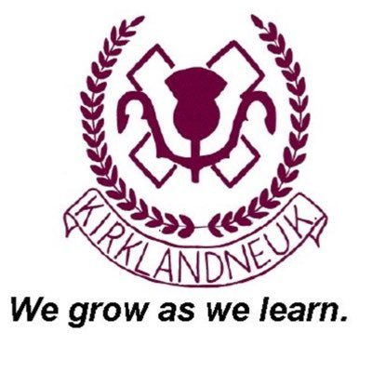
Kirklandneuk Primary School
Ard Road
Renfrew
PA4 9DA

Tel No: 0300 300 0164

Interim Head Teacher: Mrs Karen MacKechnie
Email: karen.mackechnie@renfrewshire.school

05 June 2020

Dear Parents

Firstly, I would like to introduce myself as your new Interim Head Teacher. My name is Karen MacKechnie. I have been a Head Teacher for 18 years (8 years in Perth and Kinross and 10 years in Renfrewshire) and now I have been given the privilege of looking after the Kirklandneuk Primary School Community. Please look out for a video which will be posted on SeeSaw next week where I will be introducing myself to your children.

I started in Kirklandneuk Primary School this week, having taken over from Mrs Logue last week. This week’s priority has been to get our school ready to receive our own Hub children from 09 June 2020 with a focus on cleaning, hygiene, social-distancing and risk assessment.

With only 3 weeks to go until the summer holidays, I realise that you and your families need to know what is happening with so many aspects of new school life. For now, I want to clarify the following 3 points which will provide our school community with clear direction for the meantime:

P7 Closure and S1 Transition
In line with local cluster agreement, our current P7 pupils are invited back to Kirklandneuk Primary School on THURSDAY 18 JUNE 2020. Mrs Wishart and Mrs Coyle (DHTs) will write to all P7 families early next week with the plan for this date which will include a socially-distanced Awards Ceremony with leaving gifts (including a secondary school tie). P7 pupils should wear their own clothes to school for this – we realise that many of you will have outgrown your KPS uniform.

There will also be an opportunity for current P7 pupils to visit their new secondary school on either FRIDAY 19 JUNE OR MONDAY 22 JUNE 2020. A joint communication from the secondary school and KPS will be issued next week to let you know the arrangements for this.

P1 Induction (for August 2020 entrants)
Again, in line with local cluster agreement, our current pre-school children who are due to start P1 in August 2020 are invited to Kirklandneuk Primary School on FRIDAY 19 JUNE 2020 OR MONDAY 22 JUNE 2020. Mrs Wallace (DHT) will write to all new P1 families early next week with the plan for this date which will include an induction session for P1 parents, a class visit and socially-distanced getting-to-know-you games. New P1 pupils should wear their own clothes to school for this.

School Uniform for Session 2020-2021
Kirklandneuk Primary School has a beautiful, smart uniform. Please be assured that I am absolutely committed to our formal school uniform which will be re-introduced from August 2021.

However, for next session (commencing 11 August 2020), the uniform code will change to a more relaxed version which will support new approaches to infection control and physical activity in school. There is a very clear rationale behind this decision which I will provide for you next week, but for now, I want you to have this information so that you can take advantage of the current deals online and in stores. Please now go ahead and purchase either branded or unbranded uniform as follows:

Unbranded (available from any retail outlet) | Branded (e.g. from Schoolwear Made Easy)
P1-7: plain white polo shirt | P1-7: plain white polo shirt with school logo
P1-7: black joggies or leggings

P1-6: burgundy round-neck school jumper | P1-6: burgundy round-neck school jumper with school logo
P7 only: black round-neck school jumper | P7 only: a new branded senior jumper will be gifted to new P7 pupils on their return to school in August
P1-7: black or white trainers (please purchase Velcro trainers if your child cannot manage laces)
P1-7: black indoor shoes

P1-7: black or burgundy waterproof jacket | P1-7: burgundy waterproof jacket with school logo

Unbranded P1-6 uniform:

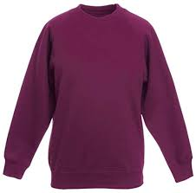
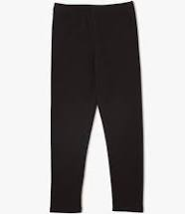
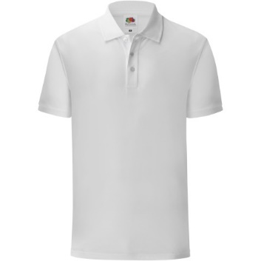

Branded P1-6 uniform:
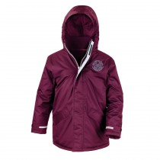
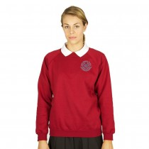
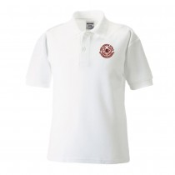

Unbranded P7 jumper:
P1-7: To minimise cross-contamination, we need to limit what pupils are bringing to school. Please DO NOT buy:
X School bag
X Pencil case or stationery (we will provide everything the children will need in school and everyone will have their own tray with their own books and stationery)

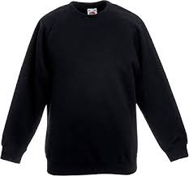

P1-7: Please DO buy:
√ Water bottle
√ Easily washable packed lunch box if you are not having a school lunch (school meals will be provided each day)

Please be assured of my commitment to the children, families and staff at Kirklandneuk Primary School. I apologise if it feels like I am making unnecessary changes at this very early stage, but I need to make sound decisions based on current guidance which will keep everyone safe for our return to school.

Finally, I am very much looking forward to meeting our current P7s and new P1s and their families later in the month and the rest of our school community in August.

I will be in touch again next week to provide further updates.

With every good wish,

K MacKechnie

Karen MacKechnie
Interim Head Teacher

