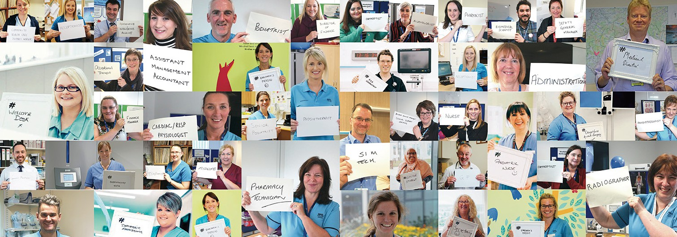

Work Experience
#HealthandCareWeek

Application form

Thank you for expressing an interest in completing the work experience programme. Please complete this application form as accurately as possible allowing us to consider your placement further.

All information provided will be treated in strict confidence

Applications open 8th June 2023
Applications close 30th June 2023

Each section must be completed fully and given to a teacher to verify the information.

Students should enter the code at the bottom of each placement box within their student information pack in their preference section.

Personal Information

Name .............................................................................................................................

Home address ................................................................................................................

E-Mail address ................................................................................................................

Telephone Number: .................................. Mobile number.............................................

Date of birth......................................................................................................................

Next of Kin ................................................. Relationship to you ......................................

Emergency Contact details

For you .......................................................................................................................

For your next of kin ....................................................................................................

School Details

School Name ..............................................................................................................

School Address ............................................................................................................

Telephone Number .......................................................................................................

School placement co-ordinator ......................................................................................

E-mail address...............................................................................................................

I am currently in receipt of free school meal entitlement Yes N/A

Year of Study........................................ UCAS application date.....................................

Qualifications already obtained and results

...................................................................................................................................................

...................................................................................................................................................

....................................................................................................................................................

..............................................................................................................................................

................................................................................................................................................
Qualification that you are currently studying for with predicted grades

..........................................................................................................................................................

..........................................................................................................................................................

..........................................................................................................................................................

..........................................................................................................................................................

..........................................................................................................................................................

I can confirm I am able to travel independently to and from the placement for the full week.
(Please check public transport times to ensure your timings prior to submitting this application)

I consent to my photography being taken throughout the work experience week and used for future promotion of work experience. I consent to the material being shown to appropriate professional staff and used in publications and in any other form or medium, including all forms of electronic publication, social media (e.g. Facebook) or distribution anywhere in the world. As a result, I understand that the general public may see the material.
Please note if under 16 parents will need to sign section at end of the form.

I consent if I am successful in gaining a placement my email address will be kept on file for future emails to stay in touch regarding my future career and communications including questionnaires.

I consent if I am successful in gaining a placement my details will be shared with Workit platform

Health

Please detail any health condition that you feel may affect you during your school placement.
e.g. Allergies, Asthma, Diabetes etc. You should also tell us about any regular medication you may need while undertaking your work experience that may have an impact on your placement time table e.g. insulin dependent diabetes needing a set lunch time etc.

..........................................................................................................................................................

..........................................................................................................................................................

.........................................................................................................................................................

Have you any specific allergies? Yes / No ......... If so, what to ..................................

I have / have not been fully vaccinated with the MMR vaccine (delete as appropriate).

Dates of my vaccinations were ...........................(first) and .................................(second)

Please note: You must be fully up to date with your MMR vaccines to be offered a placement

Supporting information
Please tell us about yourself and why you would like to complete your work experience placement with us and ultimately why you have chosen your preferences.
Please use this space to provide any supporting information to go with your application including hobbies, interests or activities outside of school which you enjoy.

..............................................................................................................................................

..............................................................................................................................................

..............................................................................................................................................

..............................................................................................................................................

..............................................................................................................................................

..............................................................................................................................................

..............................................................................................................................................

..............................................................................................................................................

..............................................................................................................................................

..............................................................................................................................................

Preferences
Please select up to two preferences however placements are not guaranteed. Preference codes are detailed within your student information pack.

Preference 1 Code: ... ...........................................................................................................

Preference 2 Code: ......................................................................................................................

Example Preference code: NURSE9

Please note: Any breach in patient confidentiality will result in immediate termination of your placement.

Student Agreement

I ......................................................................................... (Name) confirm that the above
details are correct to the best of my knowledge.

Signed .................................................................................... Date ........................................

School Teacher / Work experience coordinator supporting agreement

I confirm that he / she is a pupil at the above detailed school.
I confirm the above named student would be suitable for this placement.
(Suitability is based on: able to get to placement/location and also attaining the required qualifications for the placement where applicable)

I confirm the student meets the age requirement for their chosen placement.

I confirm the named student can be realised from school to attend work experience placement from 25th-29th September 2023

I confirm the student is entitled to receipt of free school meals N/A

I confirm the information in this application form is correct to the best of my knowledge.

Signed ................................................................................. Date ........................................

Email address .......................................................................................................................

Both student and supporting teacher will be emailed with successful details of work placement

Parent Photo consent Agreement

(If student under the age of 16)
I consent to photography being taken of the above student throughout the work experience week and used for future promotion of work experience. I consent to the material being shown to appropriate professional staff and used in publications and in any other form or medium, including all forms of electronic publication, social media (e.g. Facebook) or distribution anywhere in the world. As a result, I understand that the general public may see the material.

Signed ................................................................................. Date ........................................

Work experience application check list

School details and Next of Kin details completed
- Dates of MMR vaccines and any medical information completed
- Personal statement completed & preferences selected
- Student agreement completed and signed
- School teacher support agreement completed and signed
- Your email addresses are completed

