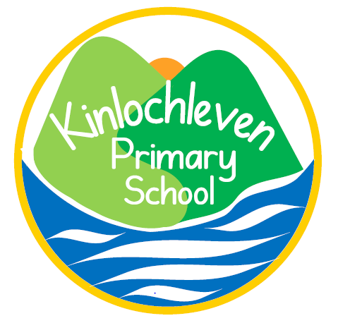
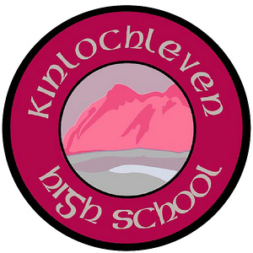
KINLOCHLEVEN 3-18 School
Phone:

Primary: 01855 832041
Secondary: 01855 832042

Email:

kinlochleven.primary@highland.sch.gov.uk
kinlochleven.high@highland.gov.uk

Web:

Riverside Road

Kinlochleven

Argyll

PH50 4QH

http://kinlochlevenps.schoolwebsite.scot
http://kinlochlevenhs.schoolwebsite.scot

Head Teacher: Rebecca Machin Depute (Secondary) : Joe Hannaway

30/1/20

All S3 pupils: Scottish National Standardised Assessments SNSA

Dear parents/carers,

Tomorrow (Friday 31st), all S3 pupils will be participating in SNSA assessments during period 1, 2 and 5 in their Maths classrooms. There will be a break between the first two periods. Pupils will be given login access and conduct them on their chromebooks. Please ensure that chromebooks are fully charged and spare chargers are brought in just in case.

SNSA assessments are nationally standardised assessments designed to align with the way we deliver education through the Curriculum for Excellence. Assessment results will help to provide additional information to teachers regarding how your child is progressing in school and to plan next steps. Pupils are assessed at key points through their education in primary 1, 4, 7 and S3 on reading, writing and numeracy. They are not required to prepare for them and assessments are as short as possible for their age and stage. If any pupil is unwell and cannot attend, provision will be made for the pupil to sit the assessment the following week. For further information on SNSA please consult the following website: https://standardisedassessment.gov.scot/parents-and-carers/
Thank you for your support,

Mr Donald Smith

Literacy Co-ordinator

