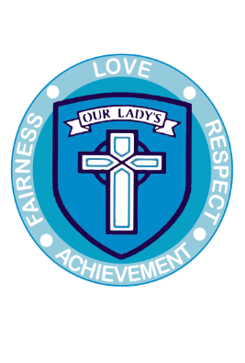

|  |  |  |  |
| --- | --- | --- | --- |
|  |  | **Our Lady’s RC Primary School**  Garth Avenue, PERTH, PH1 2LG  **School Tel No**: 01738 477570  **School Fax**: 01738 634259  **Email**: [ourladys@pkc.gov.uk](mailto:ourladys@pkc.gov.uk)  **Website**: Ourladysrcprimary.schoolwebsite.scot/home  **Twitter**: @ourladysperth  **Headteacher**: Mrs Lynne Mendes | |
| Our ref |  |
| Your ref |  |
| Date: 4th November 2020 |  |

Dear Parents/Carers

**Christmas Hamper Draw**

Last year’s hampers were a great success and we have decided to do hampers again this year with all funds raised going towards our outdoor playground shelter.

We are asking for **inexpensive donations** to be sent into school with your child. Each class will have a box at the front of the class where your child can place his or her donation. Donations will be removed and quarantined for 72 hrs.

Depending on the donations received we hope to create the following hampers**:**

**Christmas Food and Pamper Hamper for the mums and dads.**

**Christmas Goodie Hamper for the pupils**.

We are very restricted in school this year on ways we can celebrate Christmas with the children, and we thought they’d enjoy creating a hamper especially for them to raffle in the hope of taking it home at the end of term.

Suggested items are:

**Mum and Dad’s Christmas Hamper**

Christmas decorations, shower gels, bubble bath, gloves, chocolates, candles or any other item you would like to donate.

**Pupil Hamper**

Stationery – pens, pencils, note paper / note books, books, quiz books, selection box, playing cards, small board games, bath bombs, gloves, small pocket money toys or any other item you think a child would like.

Donations should be sent to class and the last date for donation is Friday 11th December 2020. Tickets/Draws for each hamper can be purchased now until 11th December on parentpay at a cost of: -

Mum & Dad’s Christmas Food and Pamper Hamper: £1.00

Pupil Hamper: £1.00

The draw will be picked during a Class Connect week commencing 14th December 2020.0

We will contact parents/winners after this to arrange uplift of hampers on Friday 18th December 2020.

If you have any queries regarding the above, please contact the school office.

Yours faithfully,

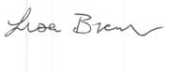

Mrs Lisa Brown

Depute Head Teacher